Updated Propagation Protocol for Bouteloua gracilis 'Blonde Ambition' PP#22,048
September, 2016 from David Salman, WAterwise Gardening LLC
david@highcountrygardens.com

Blonde Ambition'(B.A.) is not a difficult grass to propagate and has a much longer season of propagation, especially when compared to other division propagated native cultivars of Schizachyrium (Little Bluestem) and Andropogon (Big Bluestem). But you do need to have a consistent system in place.

To fertilize, use Peter's 20-20-20 or similar balanced water soluble formulation a rate of 100 to 200 ppm applied every week to two weeks. Avoid ammonium nitrate or other high N, low P and K formulations.

A well-drained composted bark/sphagnum peat potting used for perennials and other plants that like a faster draining soil is fine. A mix of sphagnum and perlite maybe a little too moisture retentive, especially in high humidity regions. B.A. tolerates dry heat quite well, but hates growing conditions with continuous high heat & humidity in a greenhouse.

B.A. can be propagated all spring and into mid-summer. It can be divided when it is in bloom in late July- Sept. but there will not be as many vegetative off-sets to work with. So March - mid-July is optimum. It can be done year-round in a heated greenhouse with long day night time interruption lights overhead and 60 F degree night temperatures. (But of course the intervals between dividing the pots is longer unless HID lighting is used during the day and early evening.)
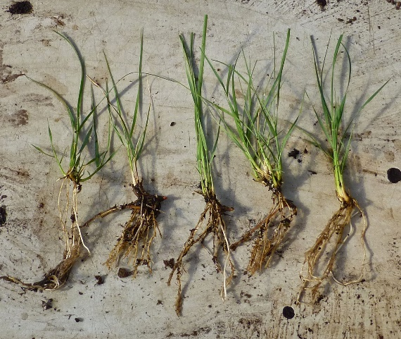
After working with many different plug and pot sizes to grow the stock, we have decided that growing, dividing and re-potting the grass in 2.5" wide x 3" deep pots (32 per flat) is the most productive. Or you can use a McConkey 4" square. (16 per square 17" x 17" flat) and just take slightly larger 2 or 3 sprig division. (see photo right to see the size of the bare-root division we re-pot back into the 2.5" pot.) We don't do it in #1 ("gallon") or larger pots any more. We generally average about 3.5 to 4 divisions per 2.5" pot giving you a 3.5 to 4X multiplier each time you divide them.

We divide it and re-pot a 1 or 2 sprig division right back into a 2.5" pot and put it under mist in full sun for 5-7 days at 16-30 minute intervals for 6-8 seconds (or hand mist 3-4 times per day in a semi-shade position). During the prime times in mid-spring to mid-summer, they are ready to re-divide in about 6-7 weeks. Just watch the sprigs initially and make sure they don't get a little gray and/or the grass blades roll inward, which indicates they are too dry. Also watch for signs of overwatering in the mist.

When we do plugs, we use a T.O. deep 72 plug and not the larger 50 or 38 plugs that are common with many grass nurseries; B.A. is a finer textured grass and doesn't need the larger plug unless specified by the buyer.

We cut the 2.5" pots back every 2 to 3 weeks to about 6" in height to encourage tillering and maximize the number of divisions in each pot. Once they begin to flower in late July, cut back to 6-8" in height every 3 to 4 weeks to keep the pots from getting overgrown. If the stock pots become over-grown, be sure to clean out the dead grass blades after they are cut back. This is important to keep the crown clean and dry and reduce the potential for crown rot. Sanitation (keeping the plants trimmed and dead grass blades removed) is always important especially for overwintered stock that is not being actively divided.

