

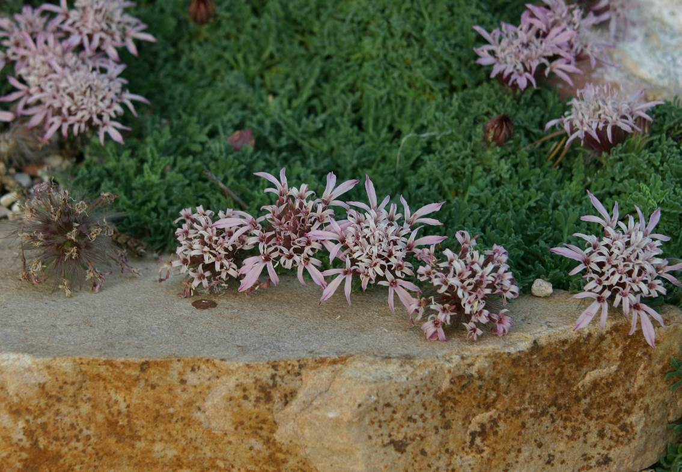
Height: 3”
Width: 10-15”
Blooms: Early summer
Sun: Full sun
Water: Moderate to dry
Hardiness: USDA zones 4-8
Culture: Well-drained, sandy
Recommended: 2016
Perennial Groundcover
This high-altitude native of the Moroccan Atlas Mountains offers beautiful features for the garden: low mat-like growth with uniquely textured, evergreen leaves, short stemmed pincushion-like dusty-rose-colored flowers, and attractive silvery seed heads. It’s truly a four-season stunner! Be sure to plant in well-drained soil with full sun exposure for best performance.
Moroccan pincushion flower
Pterocephalus depressus
www.plantselect.org

