





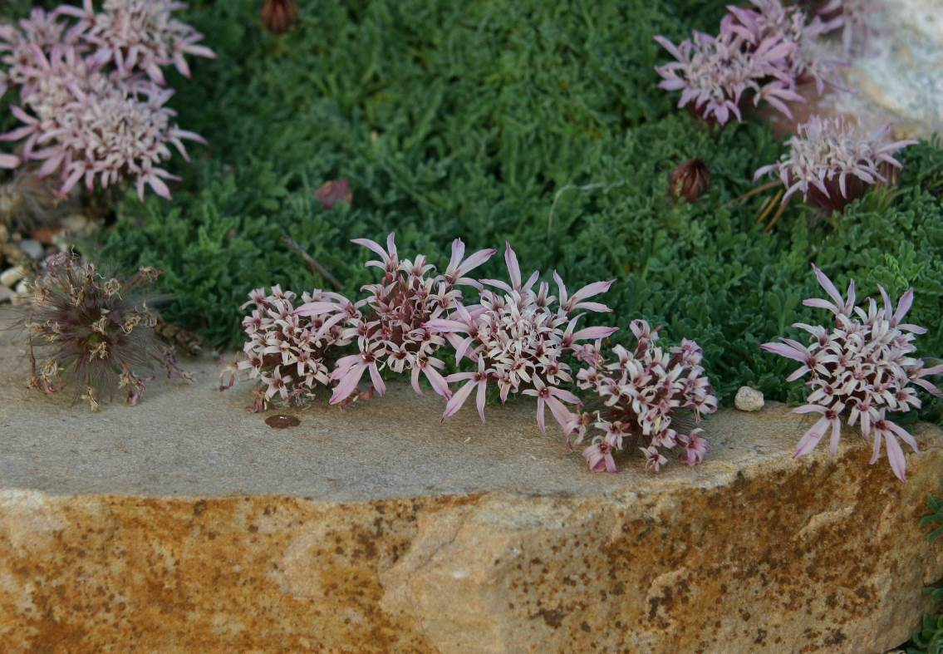
Height: 3 in.
Width: 10-15 in.
Hardiness: USDA zones 4-8
Culture: Well-drained, sandy
This high-altitude native of the Moroccan Atlas Mountains offers beautiful features for the garden: low mat-like growth with uniquely textured evergreen leaves, short stemmed pincushion-like dusty-rose-colored flowers that bloom in early summer, and attractive silvery seed heads. Be sure to plant in well-drained soil with full sun exposure for best performance.
Moroccan pincushion flower
Pterocephalus depressus
www.plantselect.org

