
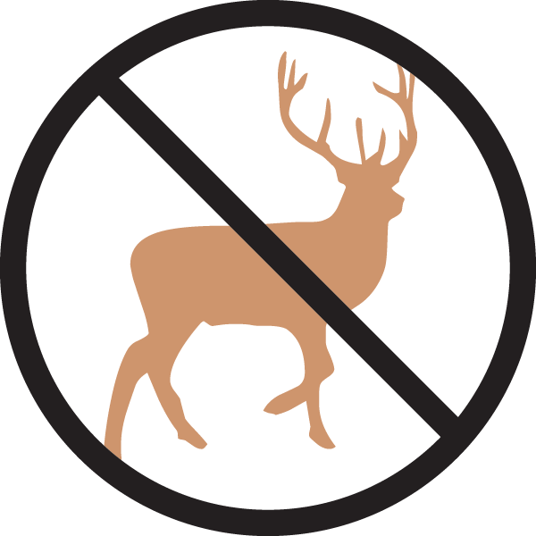
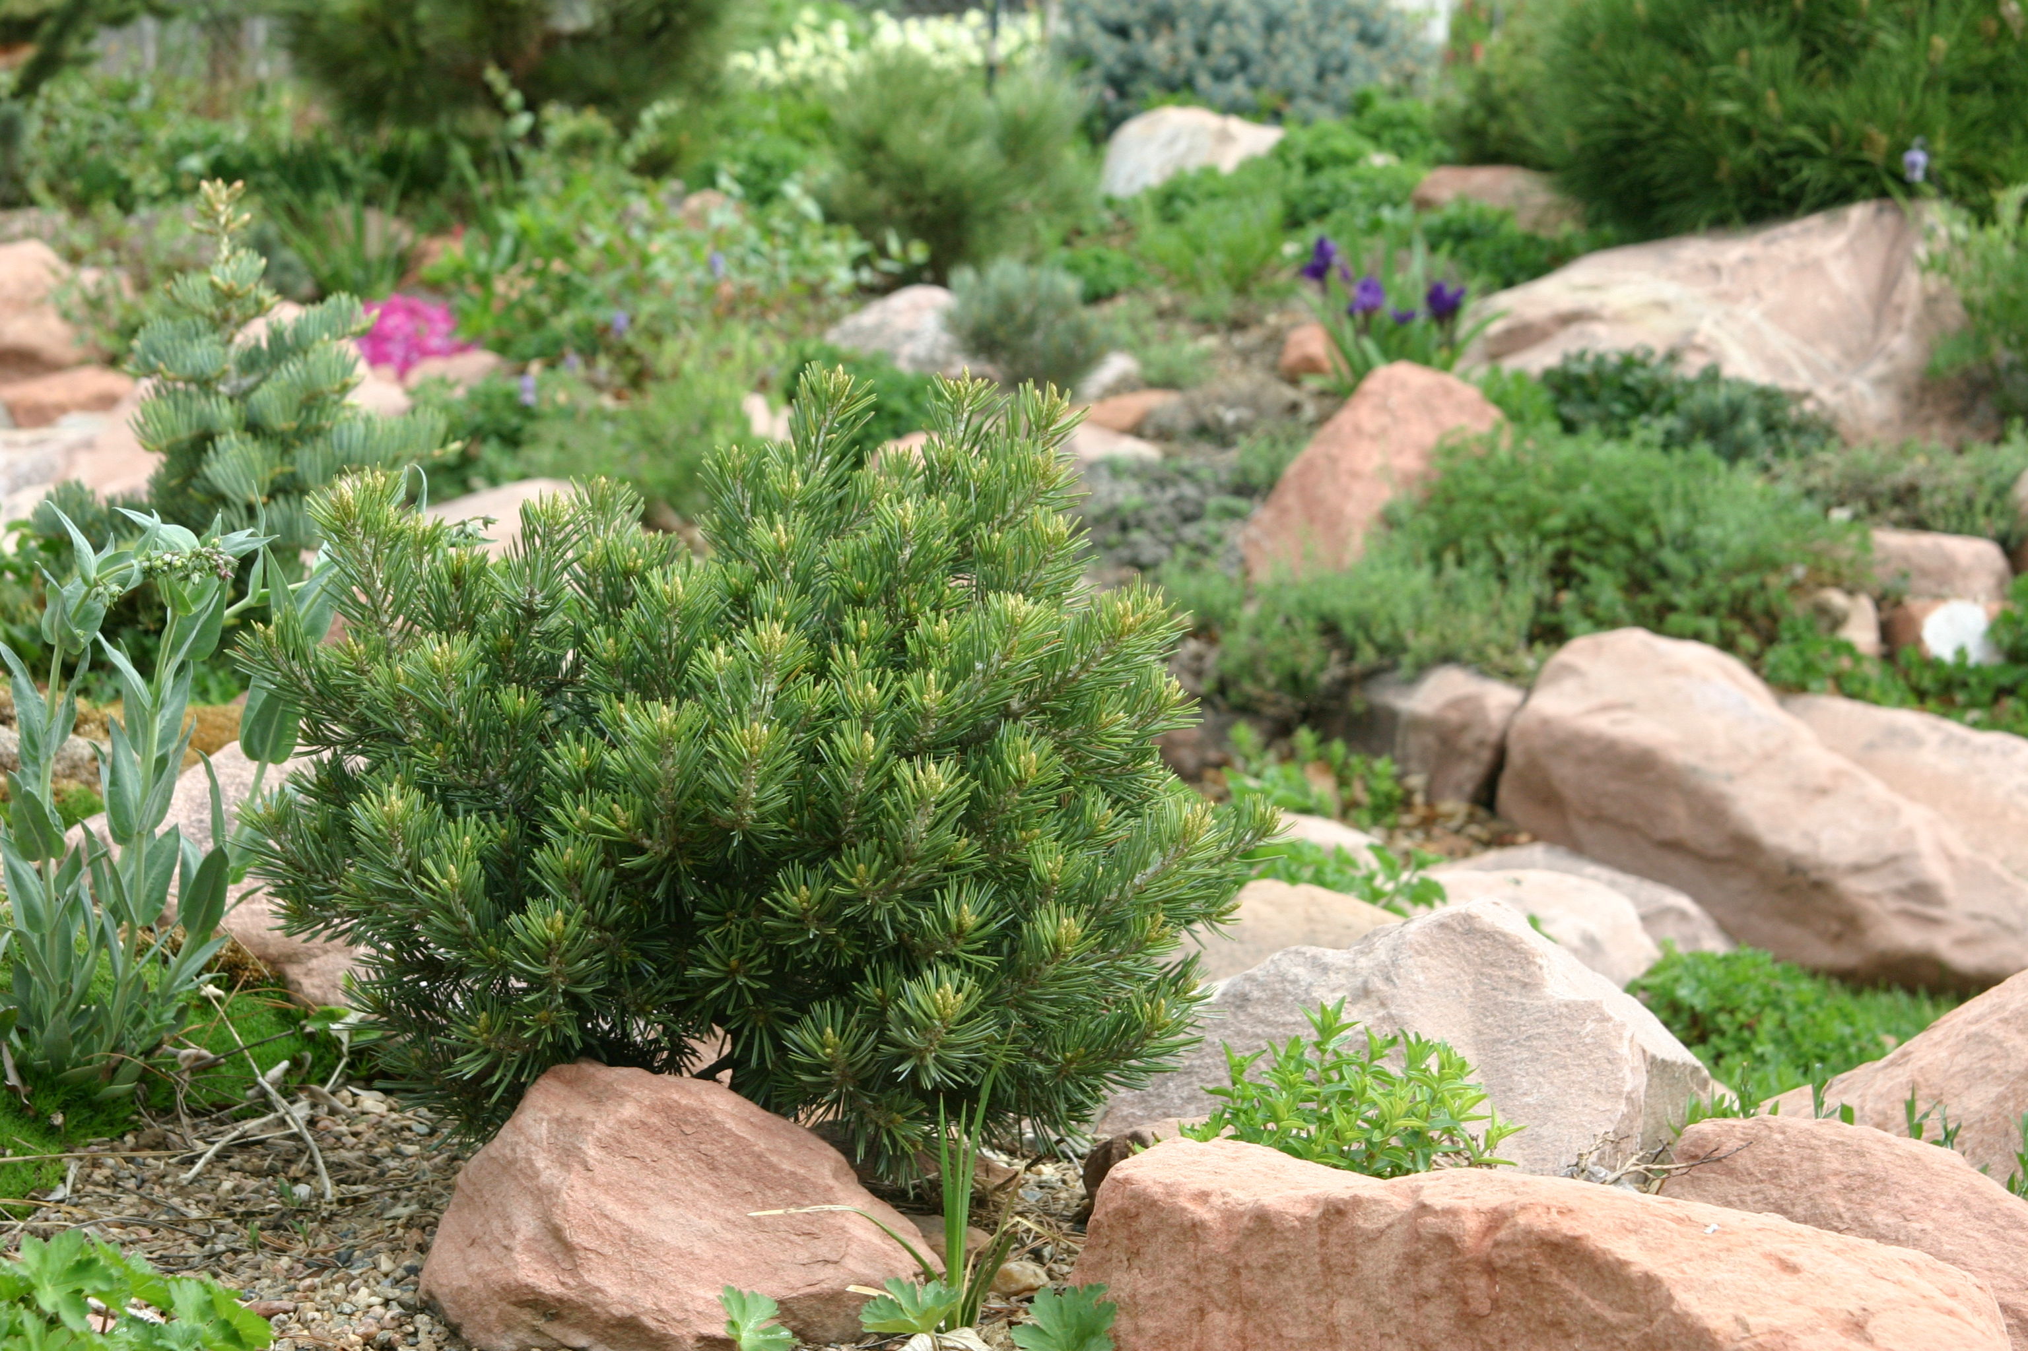

Height: 1-3”/yr (20-30” in 10 years)
Width: 1-3”/yr (20-30” in 10 years) 8-12”
Sun: Full sun
Water: Xeric
Hardiness: USDA zones 4-7
Culture: Loam or sandy soils
Recommended: 2014
Dwarf Conifer
Dwarf selections of native piñon pine that grow extremely slowly, forming tight mounds over many years. Extremely drought-tolerant dwarf conifer, adapting well to harsh conditions. Excellent evergreen choice for rock gardens and permanent containers. Selected by Jerry Morris, Denver.

Dwarf Piñion Pine
Pinus edulis selections (Farmy, Trinidad)
www.plantselect.org

