

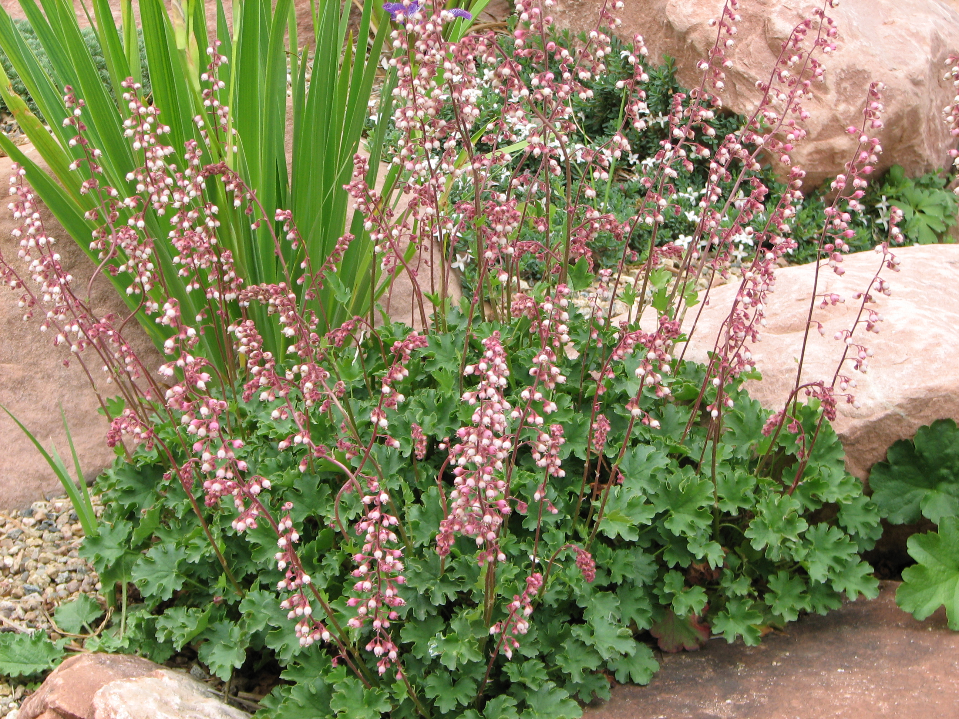

Height: 3-8”
Width: 6-10”
Blooms: May to June
Sun: Full sun to partial shade
Water: Moderate; tolerates dry shade
Hardiness: USDA zones 4-7; zone 8 cool-temperate
Culture: Loamy or sandy soil
Introduced: 2013
Perennial
This miniature, extra cute version of the well-known coralbells makes a tidy evergreen tussock of ruffled fresh green leaves. Spikes of petite rose-pink bells emerge in late spring, attracting hummingbirds and bees.
Sandia Coralbells
Heuchera pulchella
www.plantselect.org

