


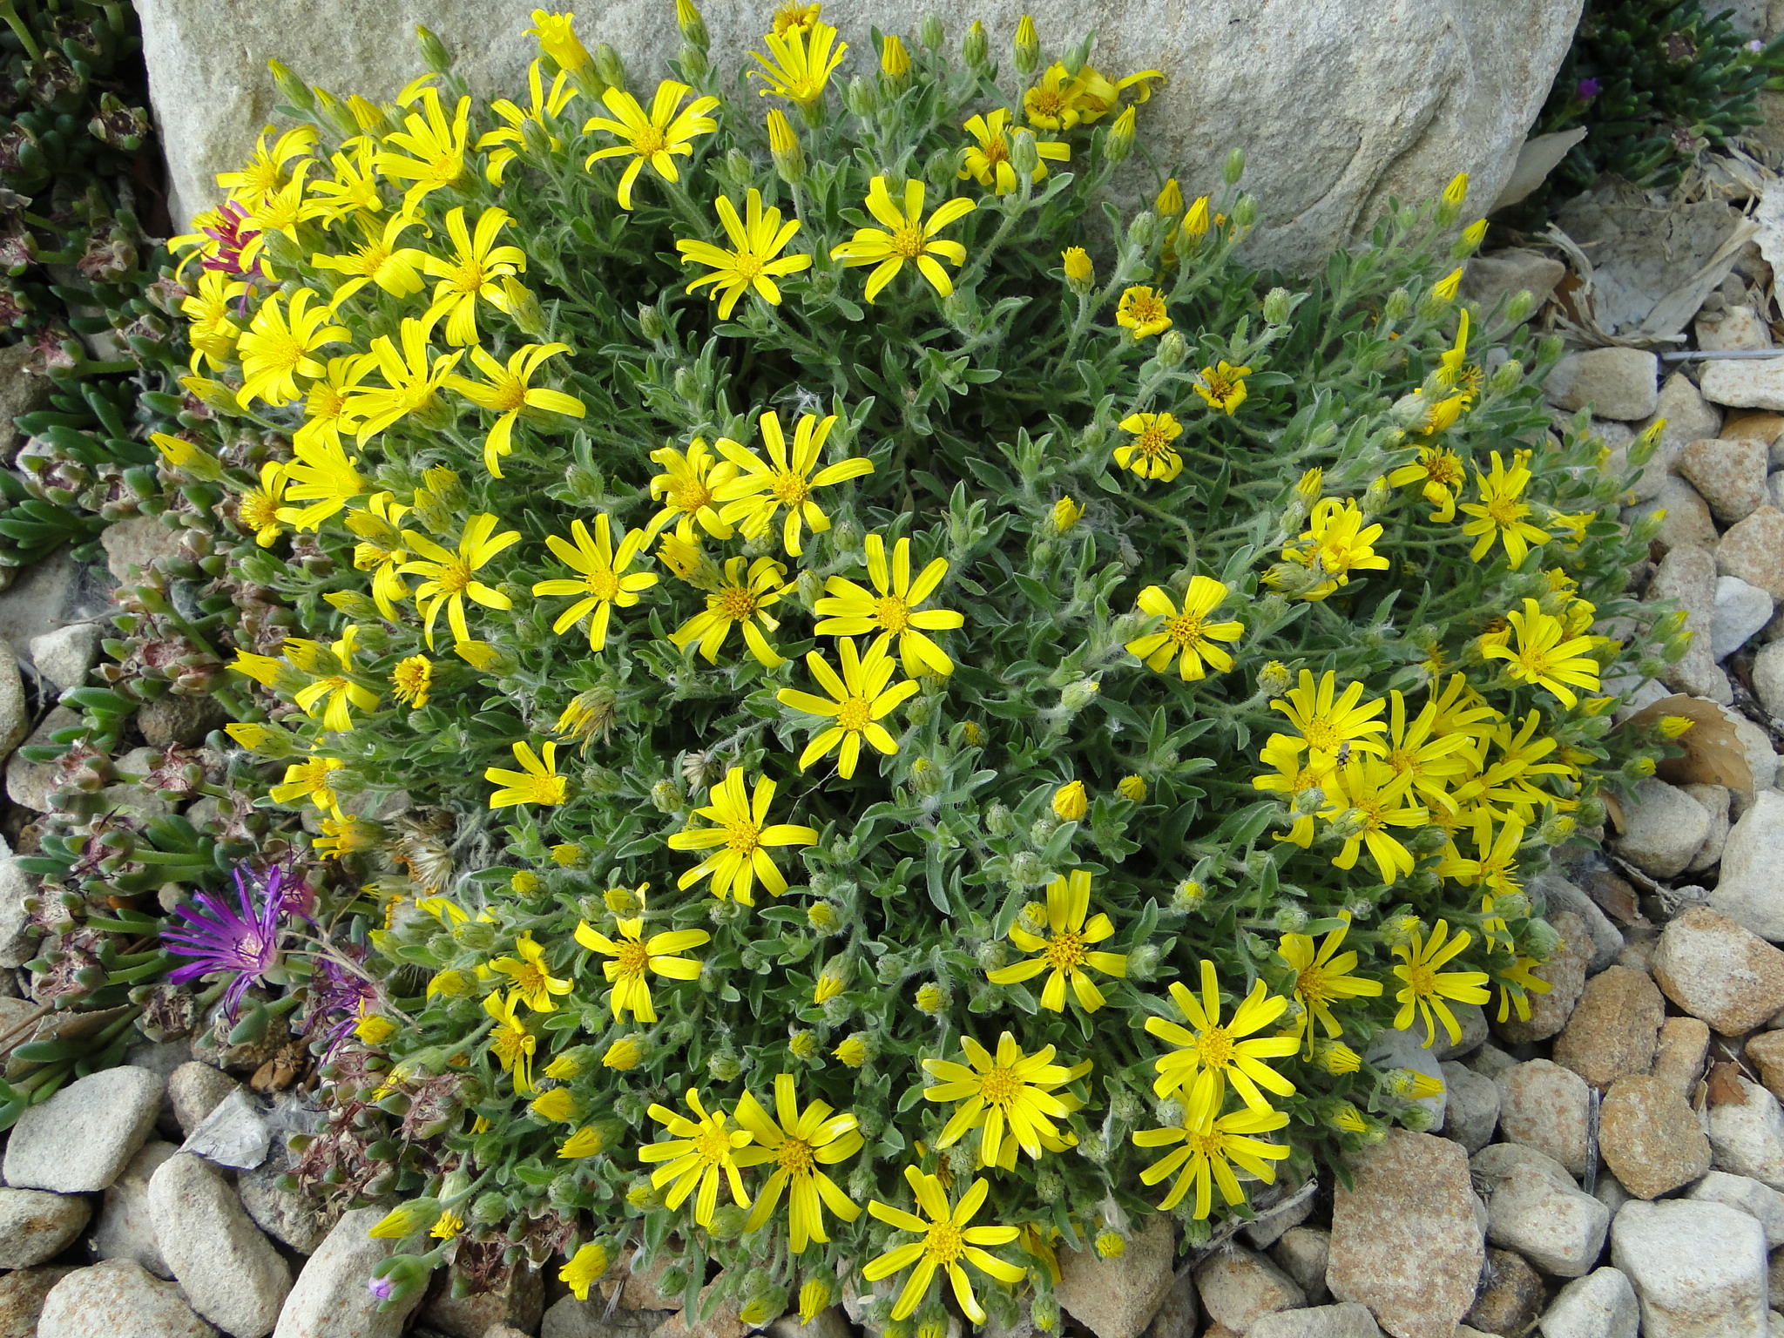

Height: 1-2”
Width: 5-10”
Blooms: Spring to fall
Sun: Full sun is best
Water: Dry to xeric
Hardiness: USDA zones 5-8
Culture: Well-drained soil
Introduced: 2015
Perennial
Tufted grey “scatter rugs” of fuzzy foliage make dense mounds in a sunny garden, clothed from late winter to fall with cheerful yellow daisies. This natural hybrid flourishes in containers as well as rock gardens. The small perennial is resistant to deer and attracts a wide range of pollinators.

Goldhill Golden-Aster
Heterotheca jonesii x villosa ‘Goldhill’
www.plantselect.org

