

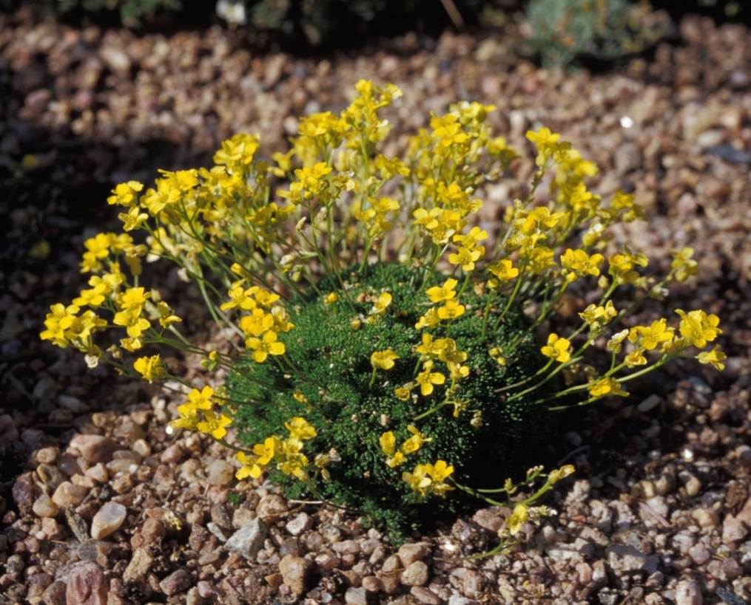






Height: 2-3 in.
Width: 6-10 in.
Hardiness: USDA zones 4-8
Culture: Well-drained, sandy
To best appreciate this tiny treasure be sure to plant it in an easily observable garden site or in a container garden. Its slow growth will delight you with bright yellow starry flowers in springtime, and tight green cushions nearly year-round. Be sure to keep it away from more vigorous growing plants so that its diminutive form can perform its best.
Yellow Stardust Draba
Draba rigida
www.plantselect.org

