

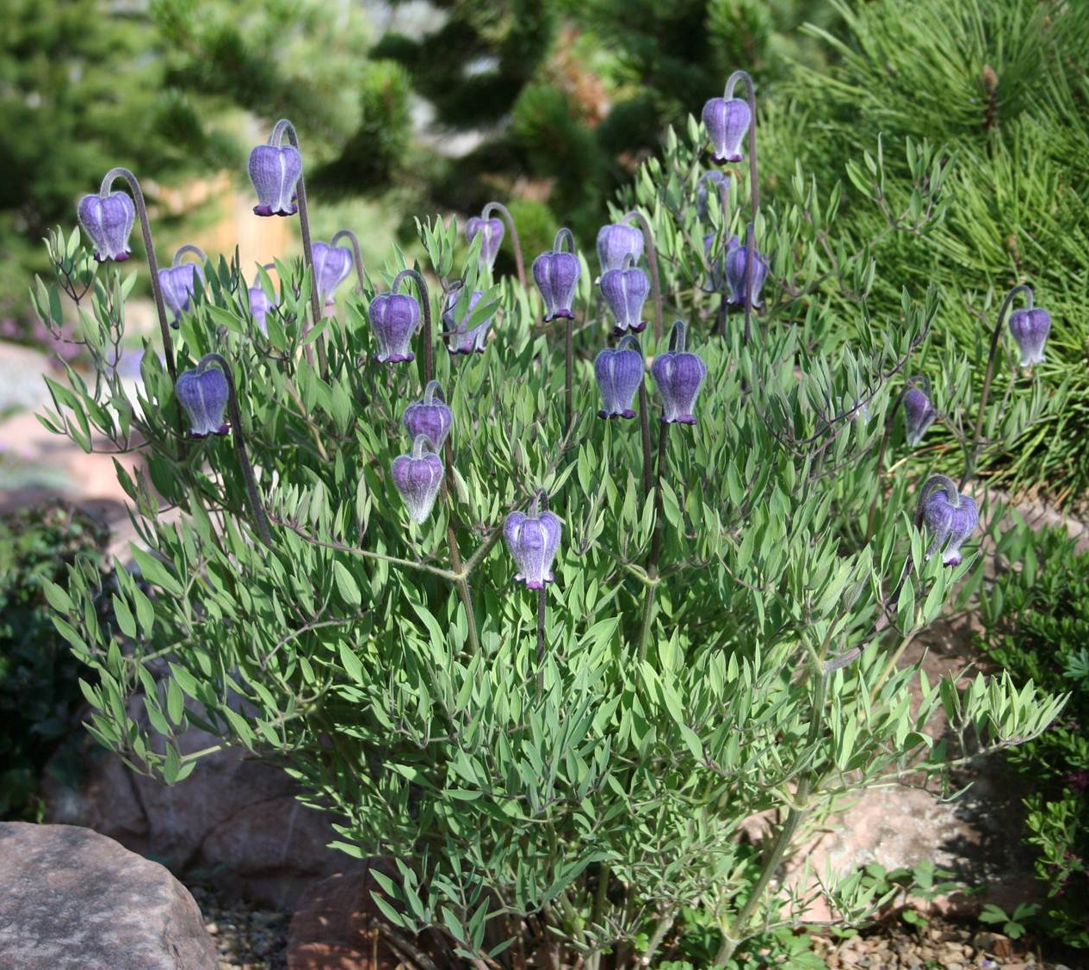

Height: 8-15”
Width: 12-18”
Blooms: May to July
Sun: Full sun
Water: Moderate to dry
Hardiness: USDA zones 4-7; zone 8 cool-temperate
Culture: Any soil; clay-tolerant
Introduced: 2013
Perennial
Long-blooming Scott’s sugarbowls make a mound of blue-green, lacy foliage topped in late spring and early summer by large, nodding blue flowers. Bees and bumblebees frequent the bell-shaped blossoms. Shimmering golden seed heads follow suit.
Scott’s Sugarbowls
Clematis scottii
www.plantselect.org

