
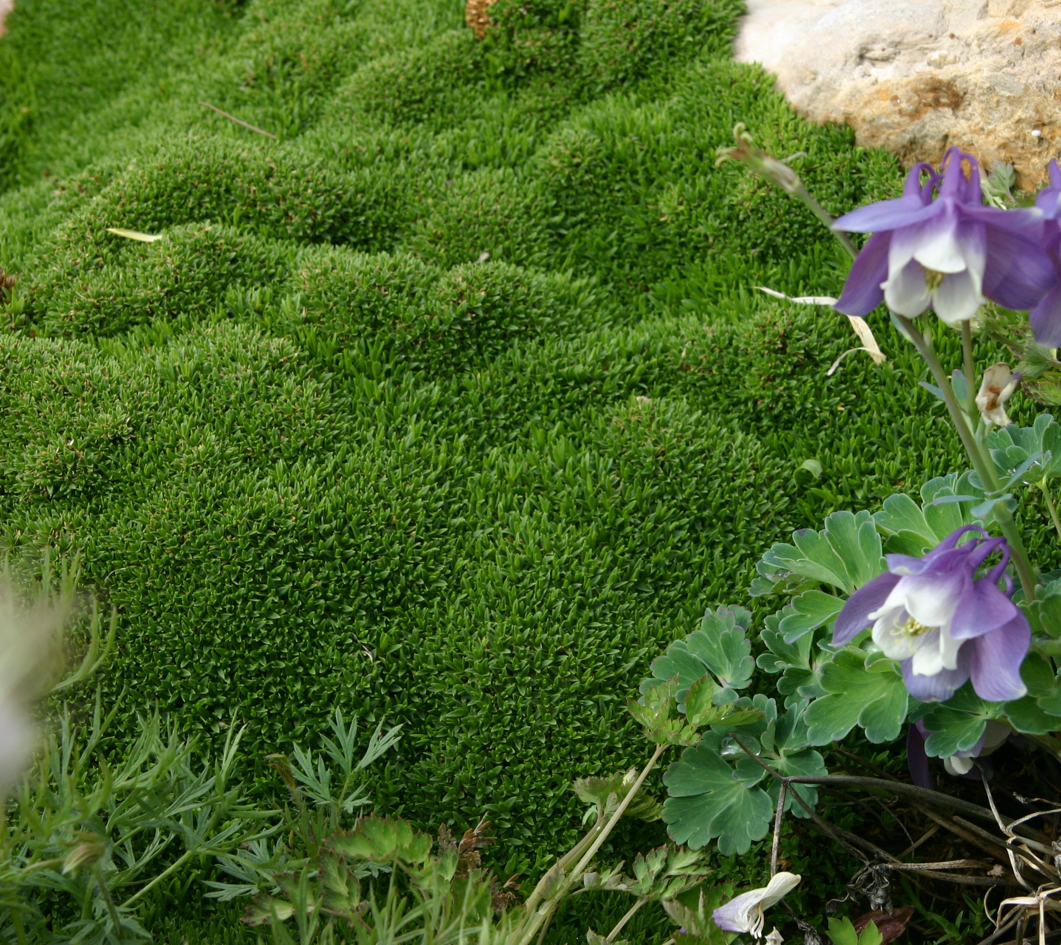

Height: 1/2”
Width: 8-12”
Blooms: White, sparse/insignificant, summer
Sun: Full sun to part shade
Water: Moderate to dry
Hardiness: USDA zones 4-8
Culture: Loam or sandy soils
Introduced: 2015
Perennial
Evergreen, exceptionally short and compact groundcover native to Oregon. Fine-textured bright green foliage resembles moss yet is very drought-tolerant. Superb for xeric and fairy gardens, permanent containers, between paving stones in paths and on patios, and as a companion to hardy cacti and succulents. Thrives in sun or partial shade.

Desert Moss
Arenaria ‘Wallowa Mountain’
www.plantselect.org

