




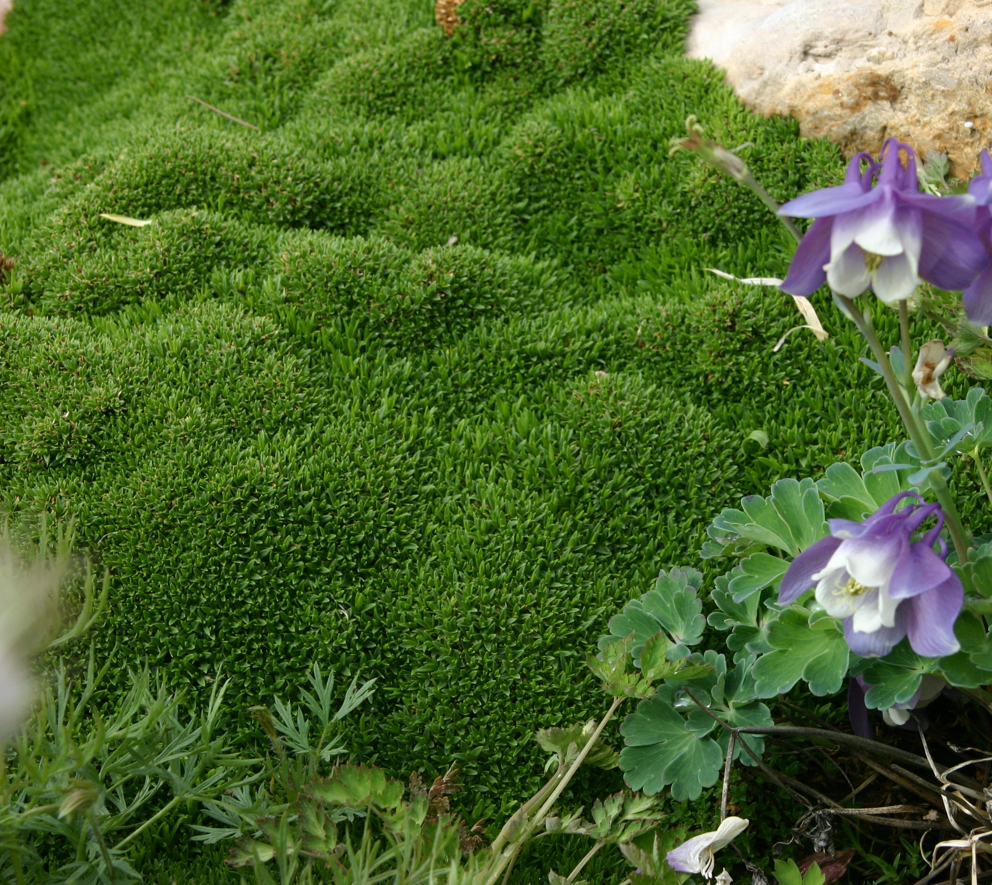

Height: 1/2 in.
Width: 8-12 in.
Hardiness: USDA zones 4-8
Culture: Loam or sandy soils
Evergreen, exceptionally short and compact groundcover native to Oregon. Fine-textured bright green foliage resembles moss yet is very drought-tolerant. Superb for xeric and fairy gardens, permanent containers, between paving stones in paths and on patios and as a companion to hardy cacti and succulents. Thrives in sun or partial shade.
Desert Moss
Arenaria ‘Wallowa Mountain’
www.plantselect.org

