
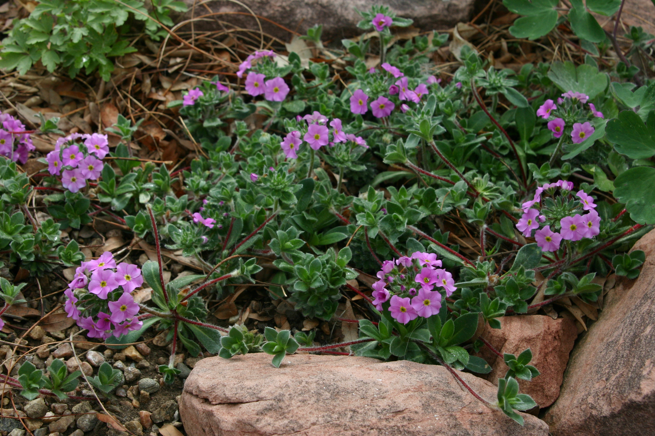

Height: 2-4”
Width: 8-12”
Blooms: Pink, early summer
Sun: Full sun to part shade
Water: Moderate to dry
Hardiness: USDA zones 3-8
Culture: Loam or sandy soils
Recommended: 2015
Perennial
Charming yet tough, this plant is rich with furry
gray-green rosettes which proliferate with strawberry like red runners to form intricate, silky semi-evergreen patches. Clusters of fragrant pink flowers rise on short stems in early summer, a focal point in rock gardens or containers. Thrives in sun or partial shade.
Silky Rock Jasmine
Androsace sarmentosa ‘Chumbyi’
www.plantselect.org

