

**Golden Flowered Prairie Zinnia**

*Zinnia grandiflora ‘*Gold on Blue’

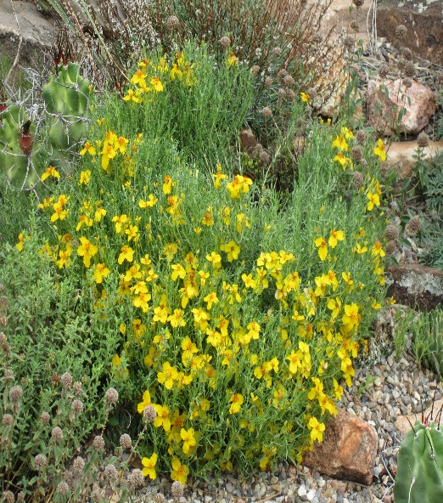

**Height: 8-10 in. Width: 18-30 in.**

‘Gold on Blue’ is an outstanding selection of native prairie zinnia chosen for its vigor, blue-green foliage and large golden flowers in summer. Excellent choice for hot, dry sites; thrives in all soil types, even dry clay. Recommended for slopes, along driveways and other places where it can spread.

**Culture:** Clay, loam, or sandy soil

**Hardiness:** USDA zones 4-8



WIND. HAIL. SNOW. SUN

**BRING IT ON**

www.plantselect.org

