



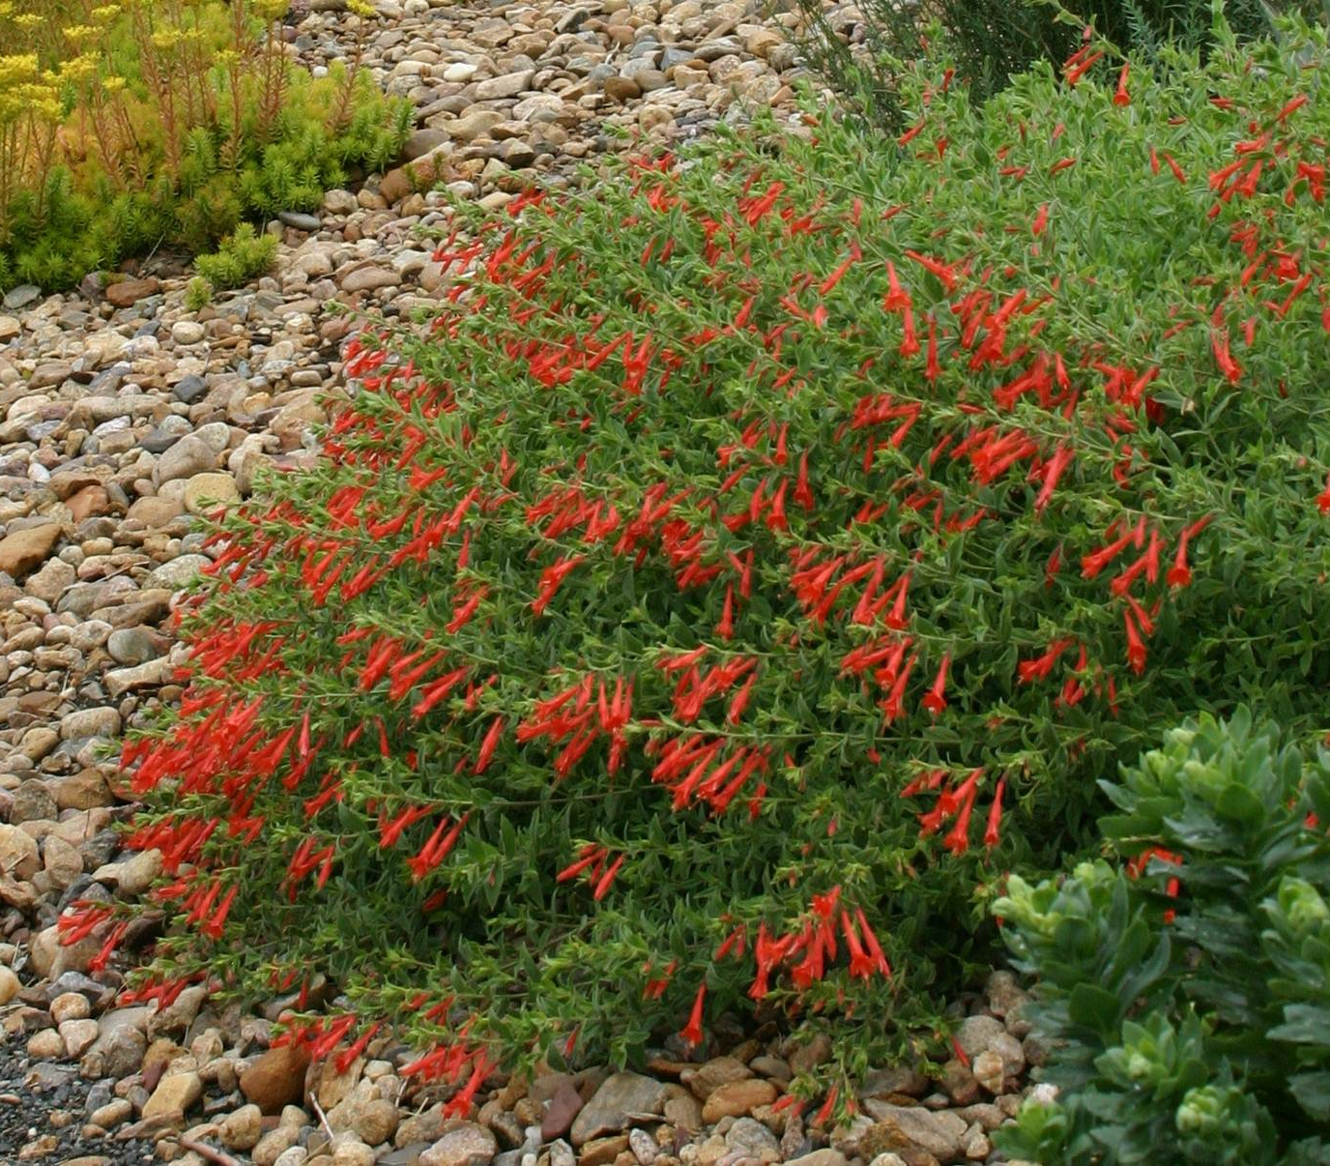
Height: 3-4”
Width: 15-20”
Blooms: Mid to late summer
Sun: Full sun to partial shade
Water: Moderate to dry
Hardiness: USDA zones 3-8
Culture: Sandy or clay loam soil
Introduced: 2001
Perennial
Rapidly spreading ground cover with masses of orange-scarlet flowers summer to fall. A selection made from seed collected in Idaho, this is the best form of California fuchsia for high altitude or cool climate gardens.

Orange Carpet® Humminbird Trumpet
Zauschneria garrettii
www.plantselect.org

