

**Orange Carpet® Hummingbird Trumpet**

*Zauschneria garrettii*

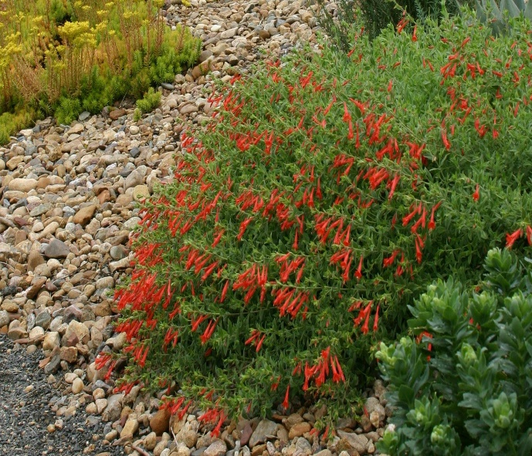

**Height: 6-8 in. Width: 18-24 in.**

Rapidly spreading ground cover with masses of orange-scarlet flowers summer to fall. A selection made from seed collected in Idaho, this is the best form of California fuchsia for high altitude or cool climate gardens.

**Culture:** Clay, loam or sandy soil

**Hardiness:** USDA zones 3-8



WIND. HAIL. SNOW. SUN

**BRING IT ON**

www.plantselect.org

