


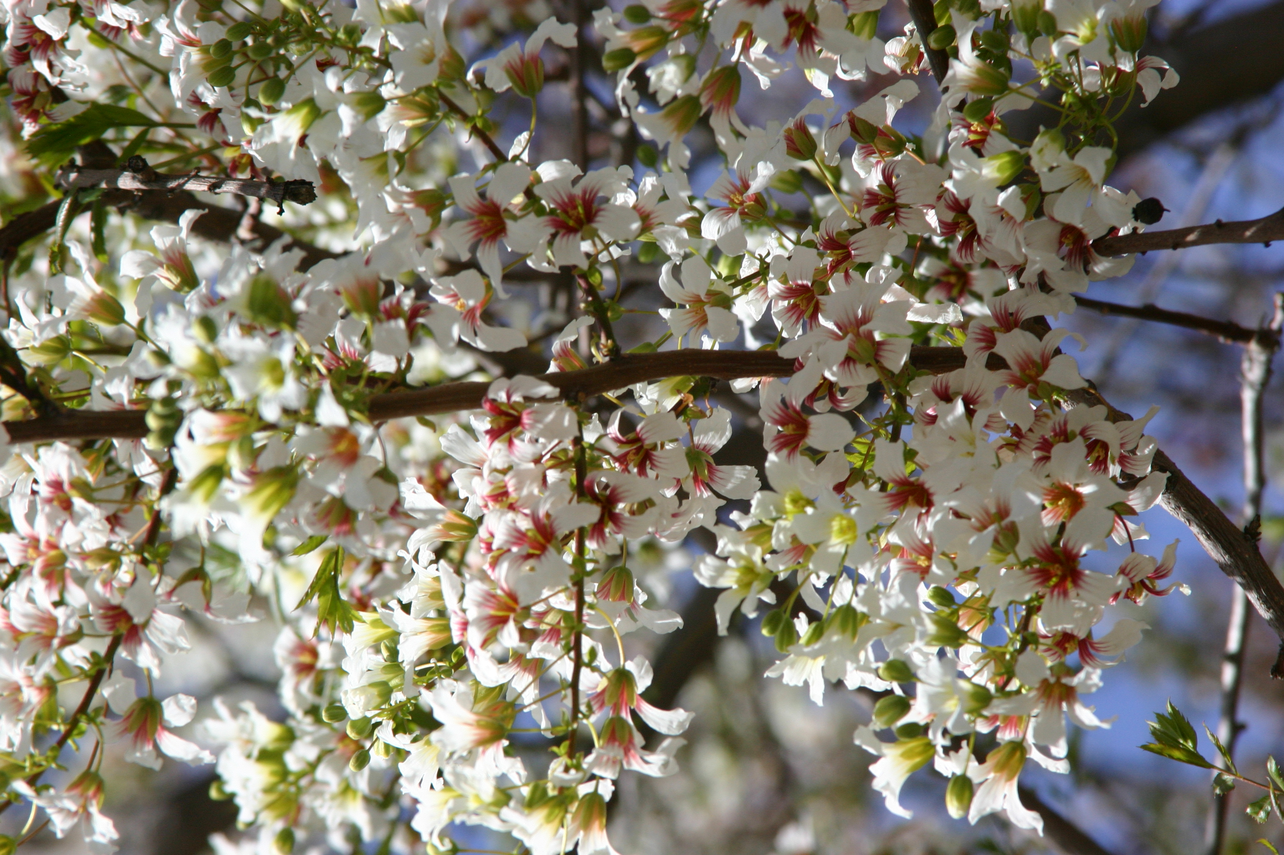
Height: 18-22’
Width: 10-15’
Blooms: April to May
Sun: Full sun to partial shade
Water: Moderate to xeric
Hardiness: USDA zones 5-8 (up to 6,000’)
Culture: Garden loam, clay, or sandy soil
Introduced: 2007
Large Shrub or Small Tree
Masses of white flowers in spring with yellow eyes turning maroon. Unique leathery seedpods form in summer and persist into winter. Vase-shaped habit with attractive, ferny leaves. Especially hardy strain developed at Green Acres Nursery in Golden, Colorado.

Clear Creek Golden Yellowhorn
Xanthoceras sorbifolium ‘Psgan’
www.plantselect.org

