

**Clear Creek Golden Yellowhorn**

*Xanthoceras sorbifolium* ‘Psgan’

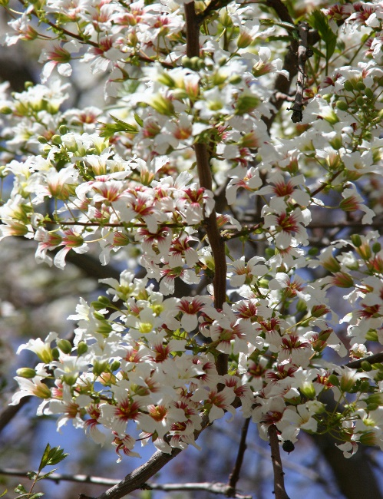

**Height: 18-22 ft. Width: 10-15 ft.**

Masses of white flowers in spring with yellow eyes turning maroon. Unique leathery seedpods form in summer and persist into winter. Vase-shaped habit with attractive, ferny leaves. Especially hardy strain developed at Green Acres Nursery in Golden, Colorado.

**Culture:** Clay, loam or sandy soil

**Hardiness:** USDA zones 5-8



WIND. HAIL. SNOW. SUN

**BRING IT ON**

www.plantselect.org

