

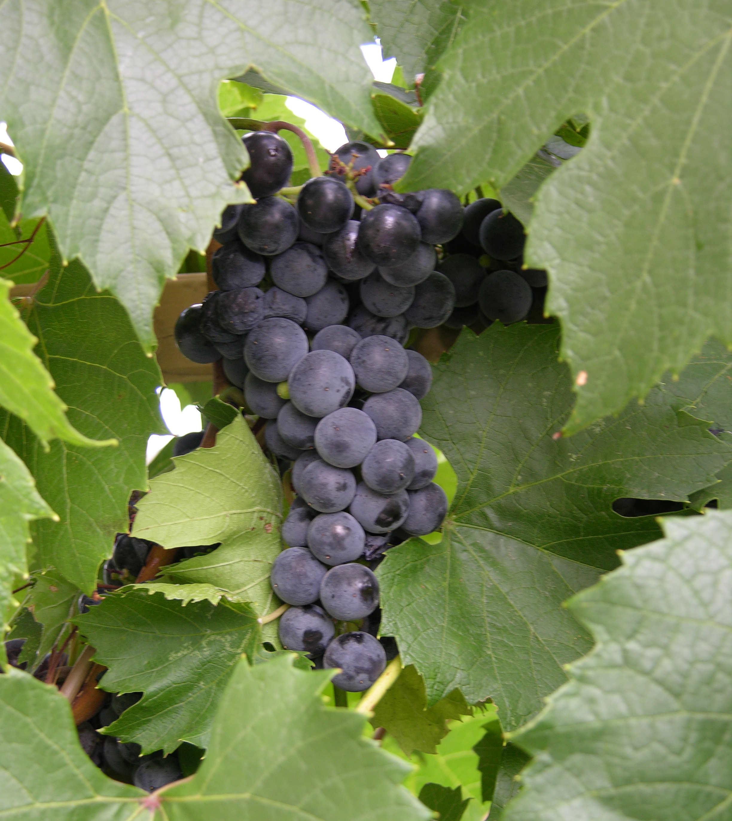
Height: 15-20’
Width: 3-8’
Blooms: Inconspicuous
Sun: Full sun to partial shade
Water: Moderate
Hardiness: USDA zones 4-9 (up to 8,000’)
Culture: Average soil
Recommended: 2008
Woody Vine
This hardy, mostly seedless, purple slip-skin grape with excellent flavor is an early season table grape variety from Elmer Swenson’s breeding program in Wisconsin. Wonderful for arbors. Tolerates alkaline soils.

St. Theresa Seedless Grape
Vitis x ‘St. Theresa Seedless’
www.plantselect.org

