

**St. Theresa Seedless Grape**

*Vitis x* ‘St. Theresa Seedless’

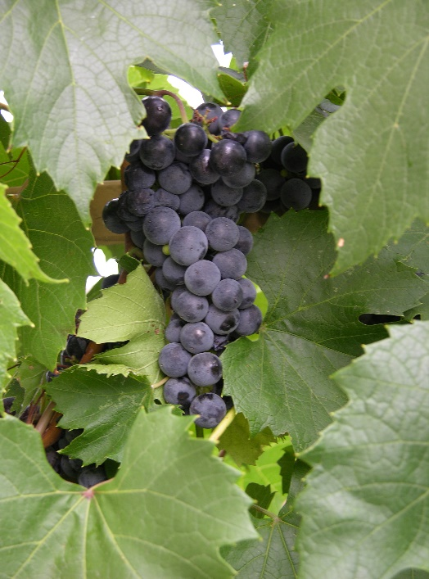

**Height: 15-20 ft. Width: 3-8 ft.**

This hardy, mostly seedless, purple slip-skin grape with excellent flavor is an early season table grape variety from Elmer Swenson’s breeding program in Wisconsin. Wonderful for arbors. Tolerates alkaline soils.

**Culture:** Loam soil

**Hardiness:** USDA zones 4-9



WIND. HAIL. SNOW. SUN

**BRING IT ON**

www.plantselect.org

