
St. Theresa Seedless Grape
Vitis x ‘St. Theresa Seedless’

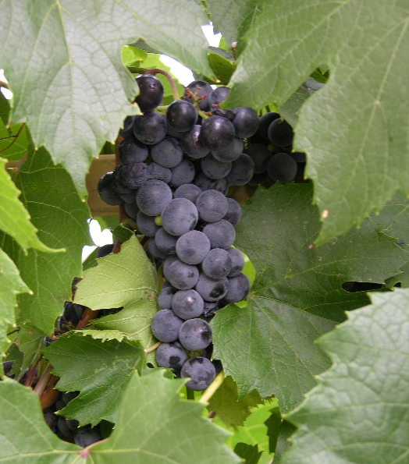




Height: 15-20 in. Width: 3-8 ft.
This hardy, mostly seedless, purple slip-skin grape with excellent flavor is an early season table grape variety from Elmer Swenson’s breeding program in Wisconsin. Wonderful for arbors. Tolerates alkaline soils.
Culture: Clay or loam soil
Hardiness: USDA zones 4-9



WIND. HAIL. SNOW. SUN
BRING IT ON

www.plantselect.org



