

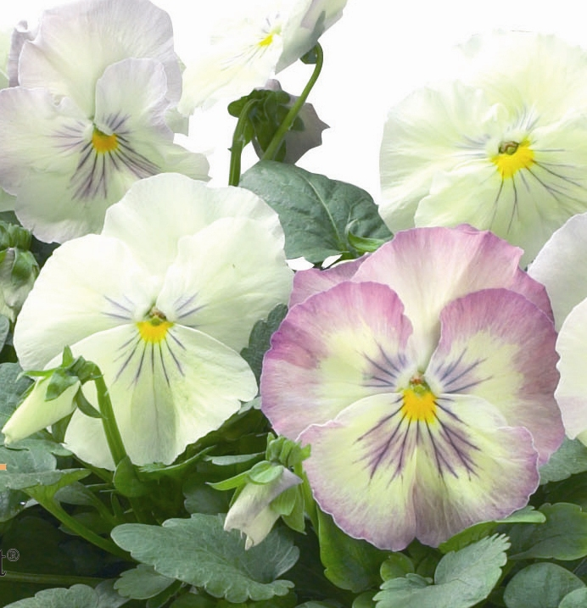
Height: 5-10”
Width: 10”
Blooms: September to summer
Sun: Full sun to partial shade
Water: Moderate
Hardiness: USDA zones 2-9 (up to 11,000’)
Culture: Average soil
Recommended: 2008
Perennial
This large-flowered pansy is a subtle blend of lemon and lilac with accents of blue. It is being marketed in partnership with Sakata Seeds in Japan, marking a joint venture in promoting this important group of winter flowering annuals. Also excellent as a bedding plant in gardens at higher altitudes or cooler climates.

Northern Lights Pansy
Viola x wittrockiana
www.plantselect.org

