

**Northern Lights Pansy**

*Viola x wittrockiana*

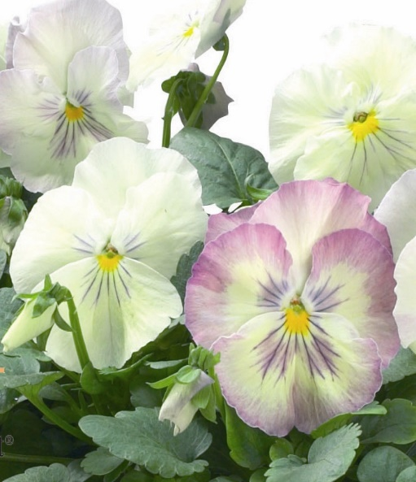

**Height: 6-10 in. Width: 10-12 in.**

This large-flowered pansy is a subtle blend of lemon and lilac with accents of blue. Also excellent as a bedding plant in gardens at higher altitudes or cooler climates.

**Culture:** Loam

**Hardiness:** USDA zones 2-9



WIND. HAIL. SNOW. SUN

**BRING IT ON**

www.plantselect.org

