

**Blue Velvet® Pansy**

*Viola x wittrockiana*

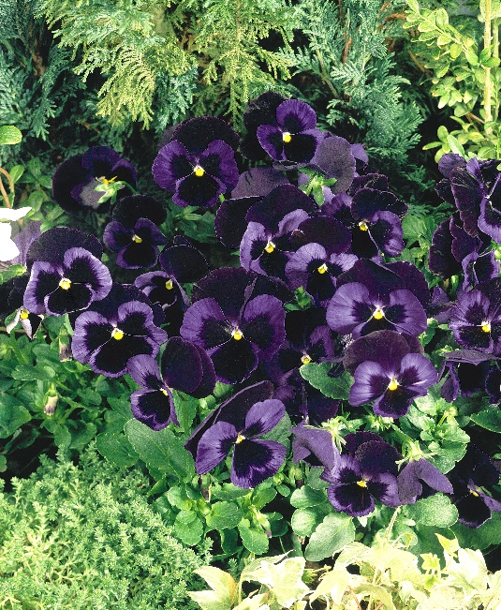

**Height: 6-10 in. Width: 10-12 in.**

Velvety navy blue flowers offer a perfect contrast to Northern Lights™ Pansy. Developed by Benary Seed Company in Germany. Best used as a winter flowering annual planted in late fall, or as a bedding plant at higher altitudes and cooler climates.

**Culture:** Loam soil

**Hardiness:** USDA zones 2-9



WIND. HAIL. SNOW. SUN

**BRING IT ON**

www.plantselect.org

