

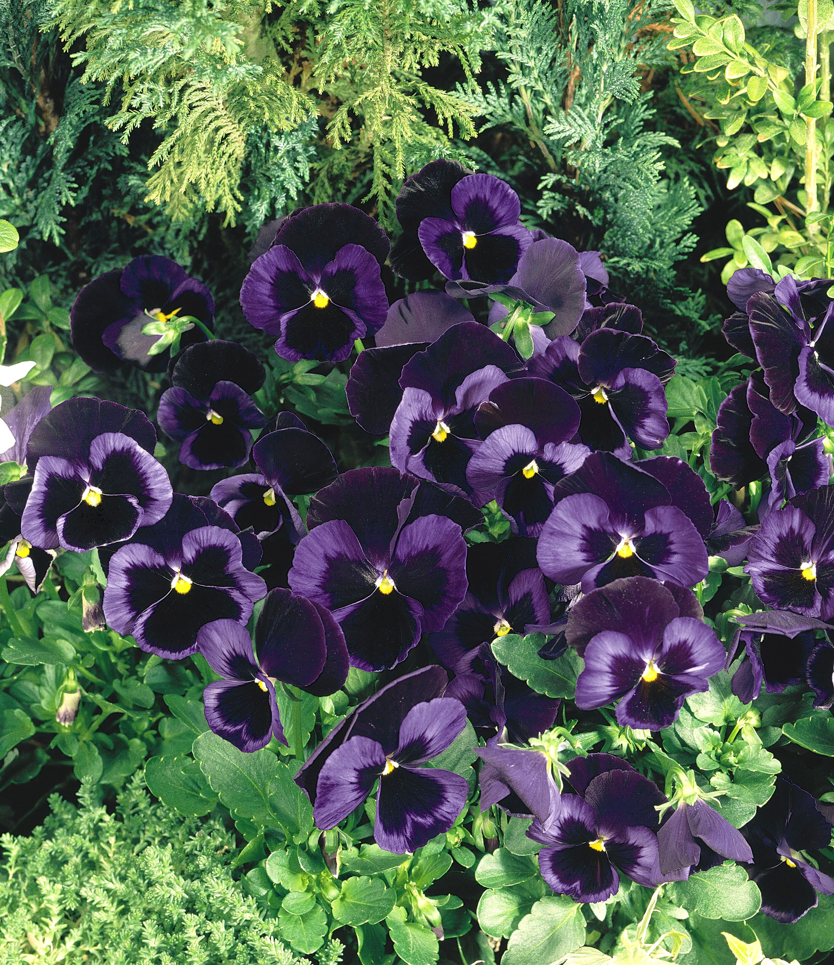
Height: 5-10”
Width: 10”
Blooms: September to summer
Sun: Full sun to partial shade
Water: Moderate
Hardiness: USDA zones 2-9 (up to 11,000’)
Culture: Average soil
Recommended: 2008
Perennial
Velvety navy blue flowers offer a perfect contrast to Northern Lights™ Pansy. Developed by Benary Seed Company in Germany. Best used as a winter flowering annual planted in late fall, or as a bedding plant at higher altitudes and cooler climates.

Blue Velvet® Pansy
Viola x wittrockiana
www.plantselect.org

