
Blue Velvet® Pansy
Viola x wittrockiana

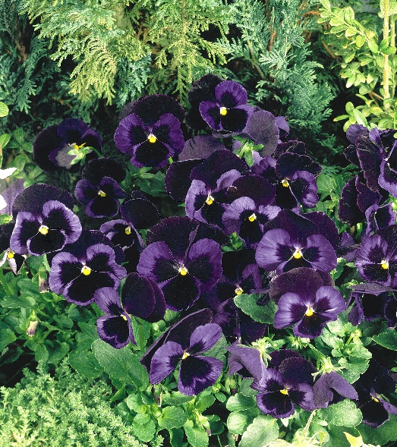





Height: 5-10 in. Width: 10 in.
Velvety navy blue flowers offer a perfect contrast to Northern Lights™ Pansy. Developed by Benary Seed Company in Germany. Best used as a winter flowering annual planted in late fall, or as a bedding plant at higher altitudes and cooler climates.
Culture: Average Soil
Hardiness: USDA zones 2-9



WIND. HAIL. SNOW. SUN
BRING IT ON

www.plantselect.org



