

**Corsican Violet**

*Viola corsica*

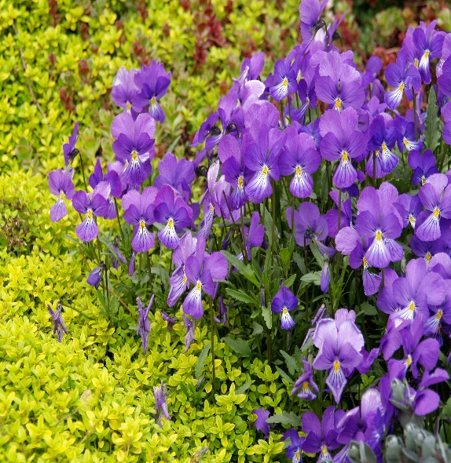

**Height: 6-8 in. Width: 6-8 in.**

A wild violet from the Mediterranean with large, one inch, bright purple flowers produced in every season. Heat tolerant perennial, it combines well with other colors in the garden and can take considerable drought. Excellent in the rock garden. Reseeds moderately.

**Culture:** Gravelly, clay or loam soil

**Hardiness:** USDA zones 3-8



WIND. HAIL. SNOW. SUN

**BRING IT ON**

www.plantselect.org

