
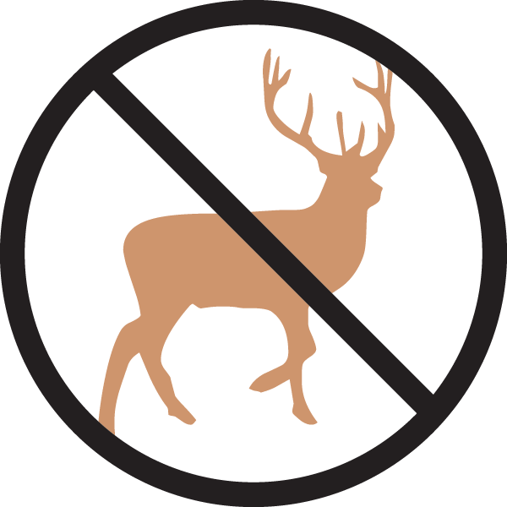


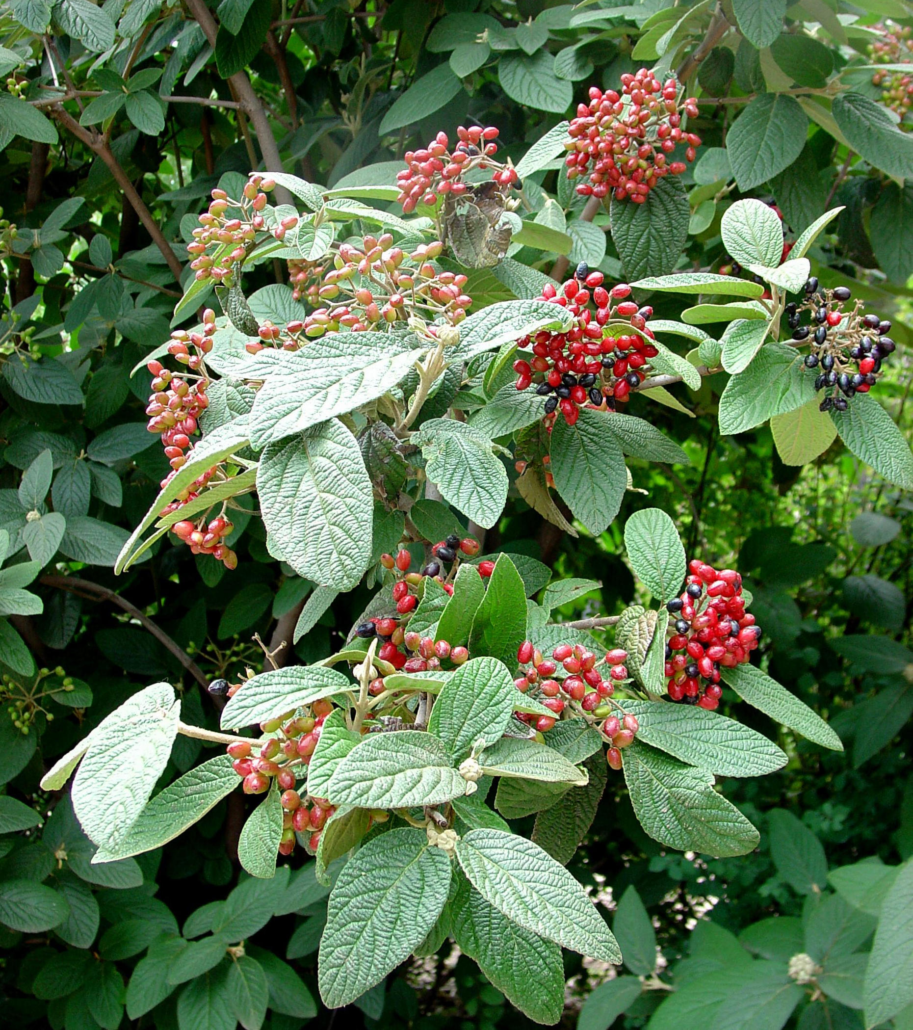
Height: 6-8’
Width: 6-8’
Blooms: Late spring
Sun: Full sun to partial shade
Water: Moist to average soil
Hardiness: USDA zones 4b-9
Culture: Ordinary soil
Introduced: 1997
Shrub
Stately, richly textured shrub with deep green leaves that are practically evergreen most winters. Spectacular white bloom in spring with rich red berries through the summer and fall. A wonderful four season shrub hybridized at the U.S. National Arboretum in Washington, D.C. It provides an effect in the landscape similar to evergreen rhododendrons, and it is much more widely adaptable.

Alleghany Viburnum
Viburnum x rhytidophylloides ‘Alleghany’
www.plantselect.org

