

**Mini Man™ dwarf Manchurian viburnum**

*Viburnum burejaeticum ‘P017S’*

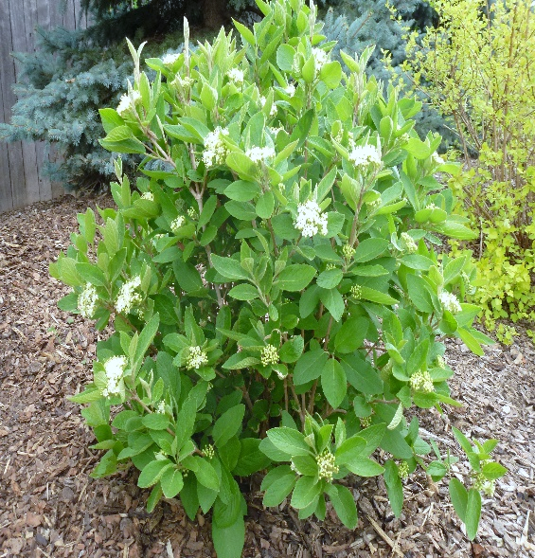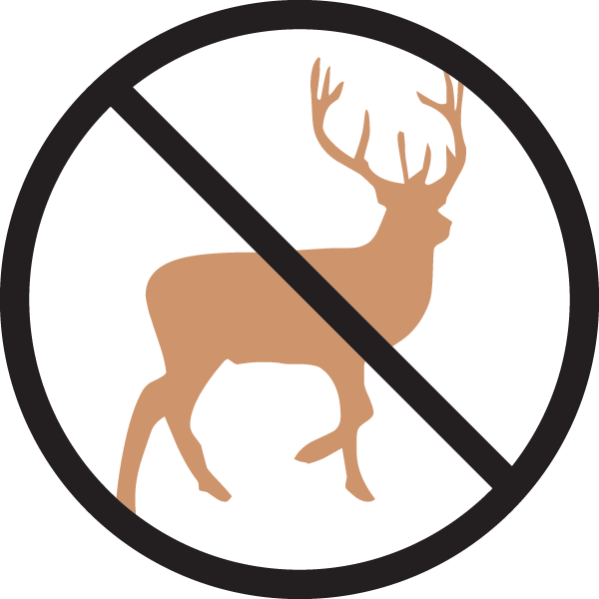

**Height: 4-6 ft. Width: 4-6 ft.**

An easy-to-grow shrub that offers the same great features of the species: medium green, velvety leaves in summer, clusters of white flowers in spring, persistent red to blue-black fruit. Excellent smaller shrub for cold climates.

**Culture:** Loamy

**Hardiness:** USDA zones 3-9



WIND. HAIL. SNOW. SUN

**BRING IT ON**

www.plantselect.org

