
Alleghany Viburnum
Viburnum x rhytidophylloides ‘Alleghany’


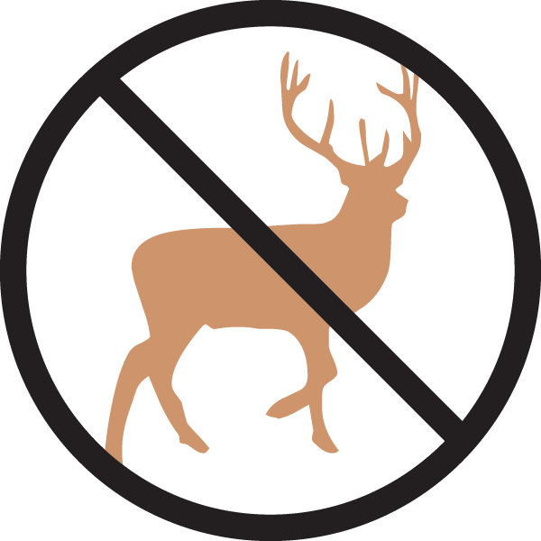





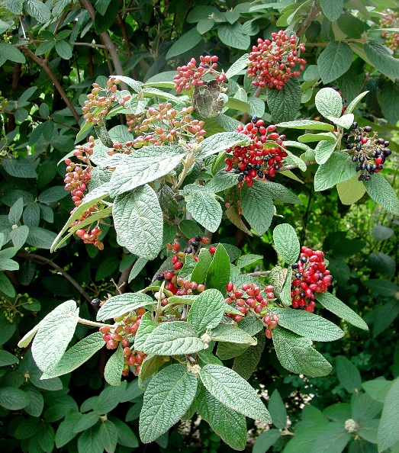

Height: 8-10 ft. Width: 8-10 ft.
Stately, richly textured shrub with deep green leaves that are practically evergreen most winters. Spectacular white bloom in spring with rich red berries through the summer and fall. A wonderful four season shrub hybridized at the U.S. National Arboretum in Washington, D.C.
Culture: Clay, loam or sandy soil
Hardiness: USDA zones 4b-8



WIND. HAIL. SNOW. SUN
BRING IT ON

www.plantselect.org



