

**Alleghany Viburnum**

*Viburnum x rhytidophylloides* ‘Alleghany’

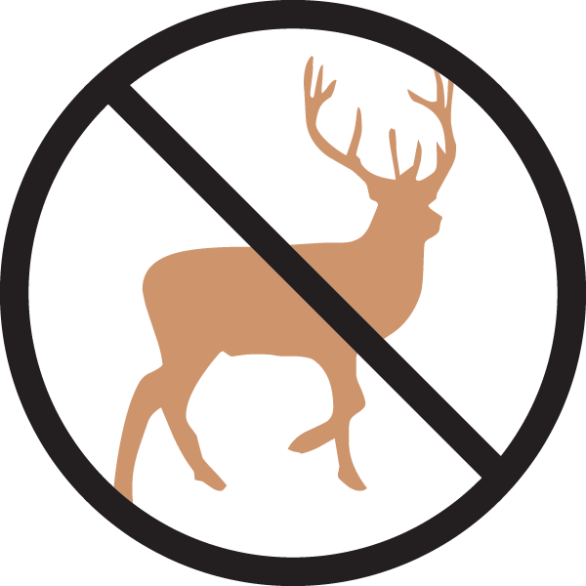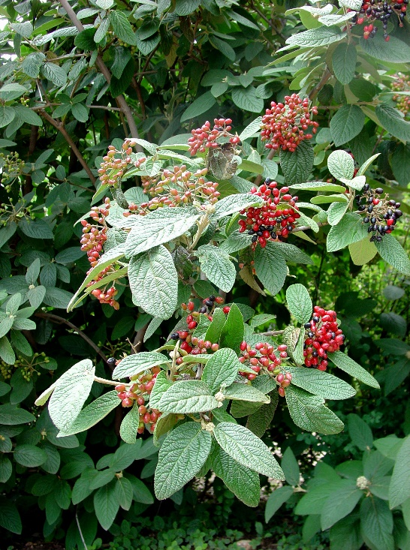

**Height: 8-10 ft. Width: 8-10 ft.**

Stately, richly textured shrub with deep green leaves that are practically evergreen most winters. Spectacular white bloom in spring with rich red berries through the summer and fall. A wonderful four season shrub hybridized at the U.S. National Arboretum in Washington, D.C.

**Culture:** Clay, loam or sandy soil

**Hardiness:** USDA zones 4b-8



WIND. HAIL. SNOW. SUN

**BRING IT ON**

www.plantselect.org

