


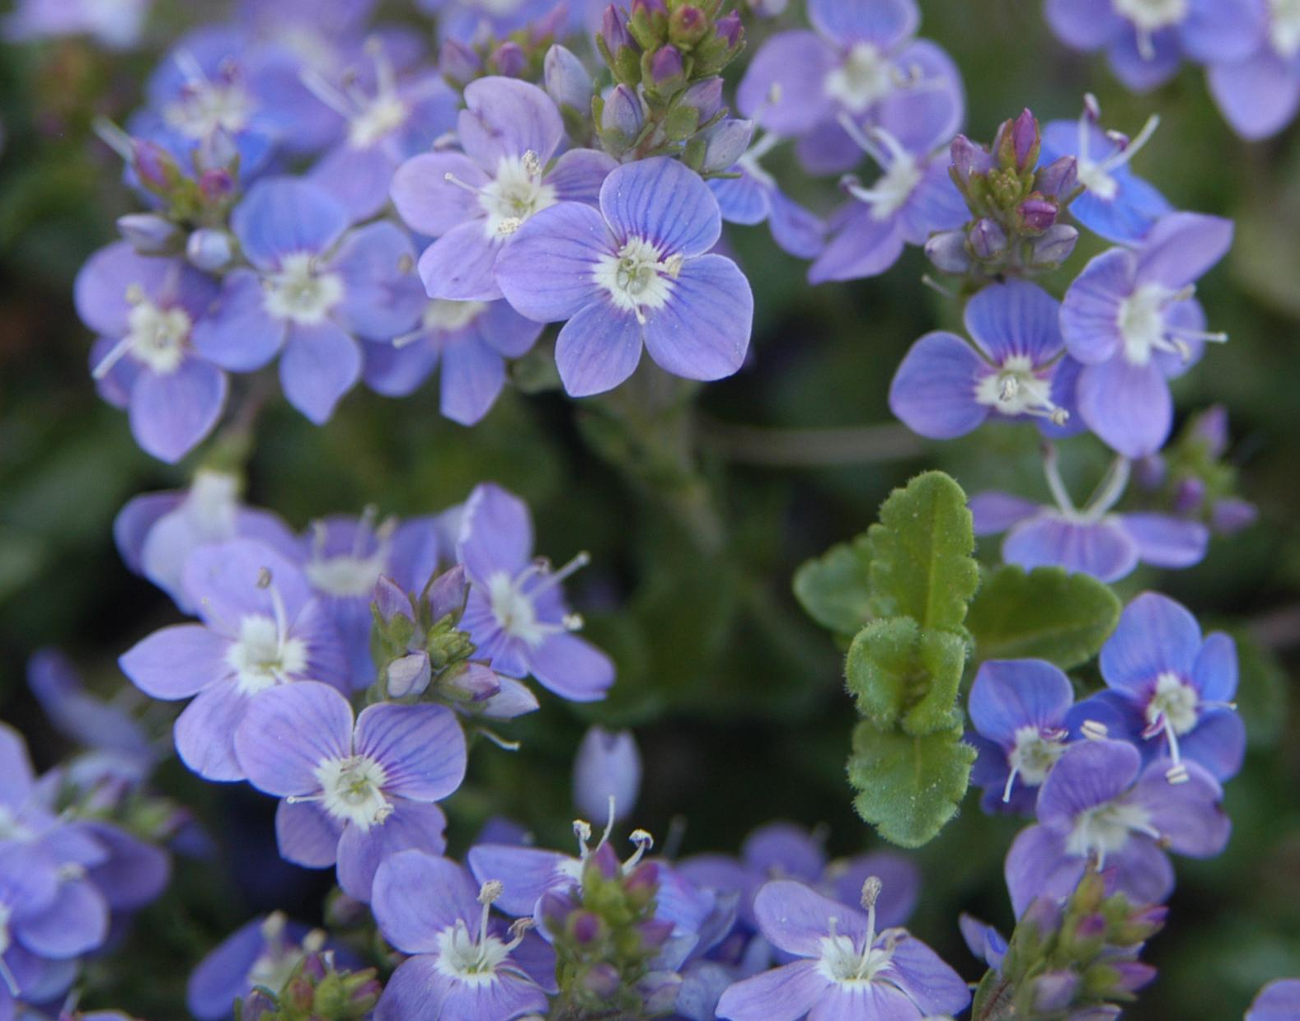
Height: 3”
Width: 20-30”
Blooms: April to June; scattered blooms later
Sun: Full sun to partial shade
Water: Moderate to dry
Hardiness: USDA zones 3-9
Culture: Average loam, clay, or sandy soil
Introduced: 2003
Evergreen groundcover
This exceptional evergreen groundcover, a hybrid between Veronica liwanesis and Veronica pectinata, combines the best qualities of both parents and demonstrates hybrid vigor as well. The tiny blue flowers appear in a solid mass in the spring, with scattered blooms throughout the season. Fast growing and vigorous.

Crystal River® Veronica
Veronica ‘Reavis’
www.plantselect.org

