

**Crystal River® Veronica**

*Veronica ‘Reavis’*

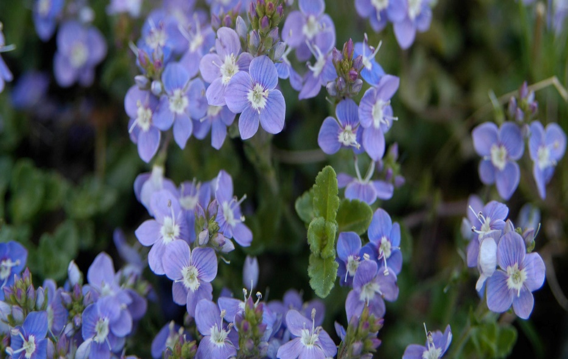

**Height: 4 in. Width: 18-24 in.**

This exceptional evergreen groundcover is covered with tiny blue flowers that appear in a solid mass in the spring, with scattered blooms throughout the season. Fast growing and vigorous.

**Culture:** Clay, loam or sandy soil

**Hardiness:** USDA zones 3-7



WIND. HAIL. SNOW. SUN

**BRING IT ON**

www.plantselect.org

