
Crystal River® Veronica
Veronica ‘Reavis’



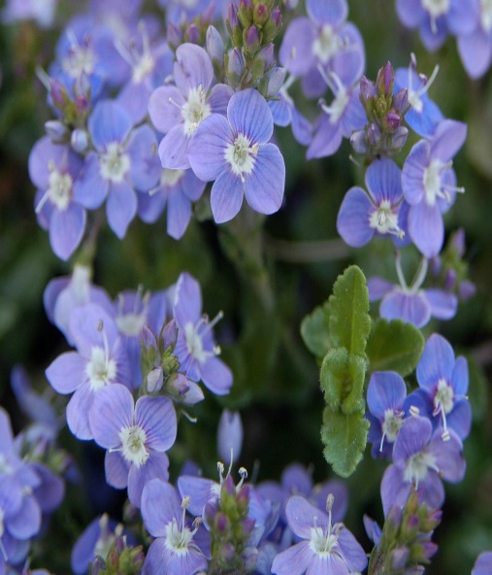





Height: 3 ft. Width: 20-30 in.
This exceptional evergreen groundcover is covered with tiny blue flowers that appear in a solid mass in the spring, with scattered blooms throughout the season. Fast growing and vigorous.
Culture: Clay, loam or sandy soil
Hardiness: USDA zones 3-10



WIND. HAIL. SNOW. SUN
BRING IT ON

www.plantselect.org



