
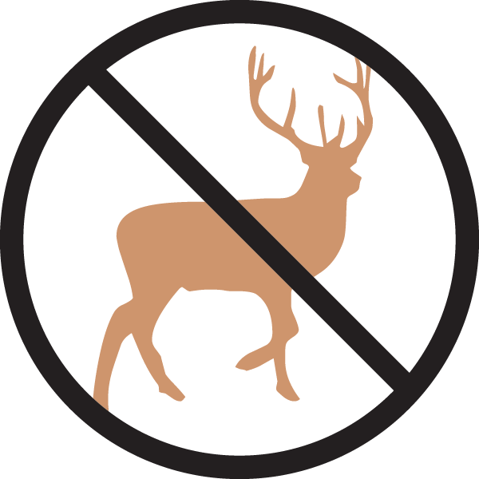

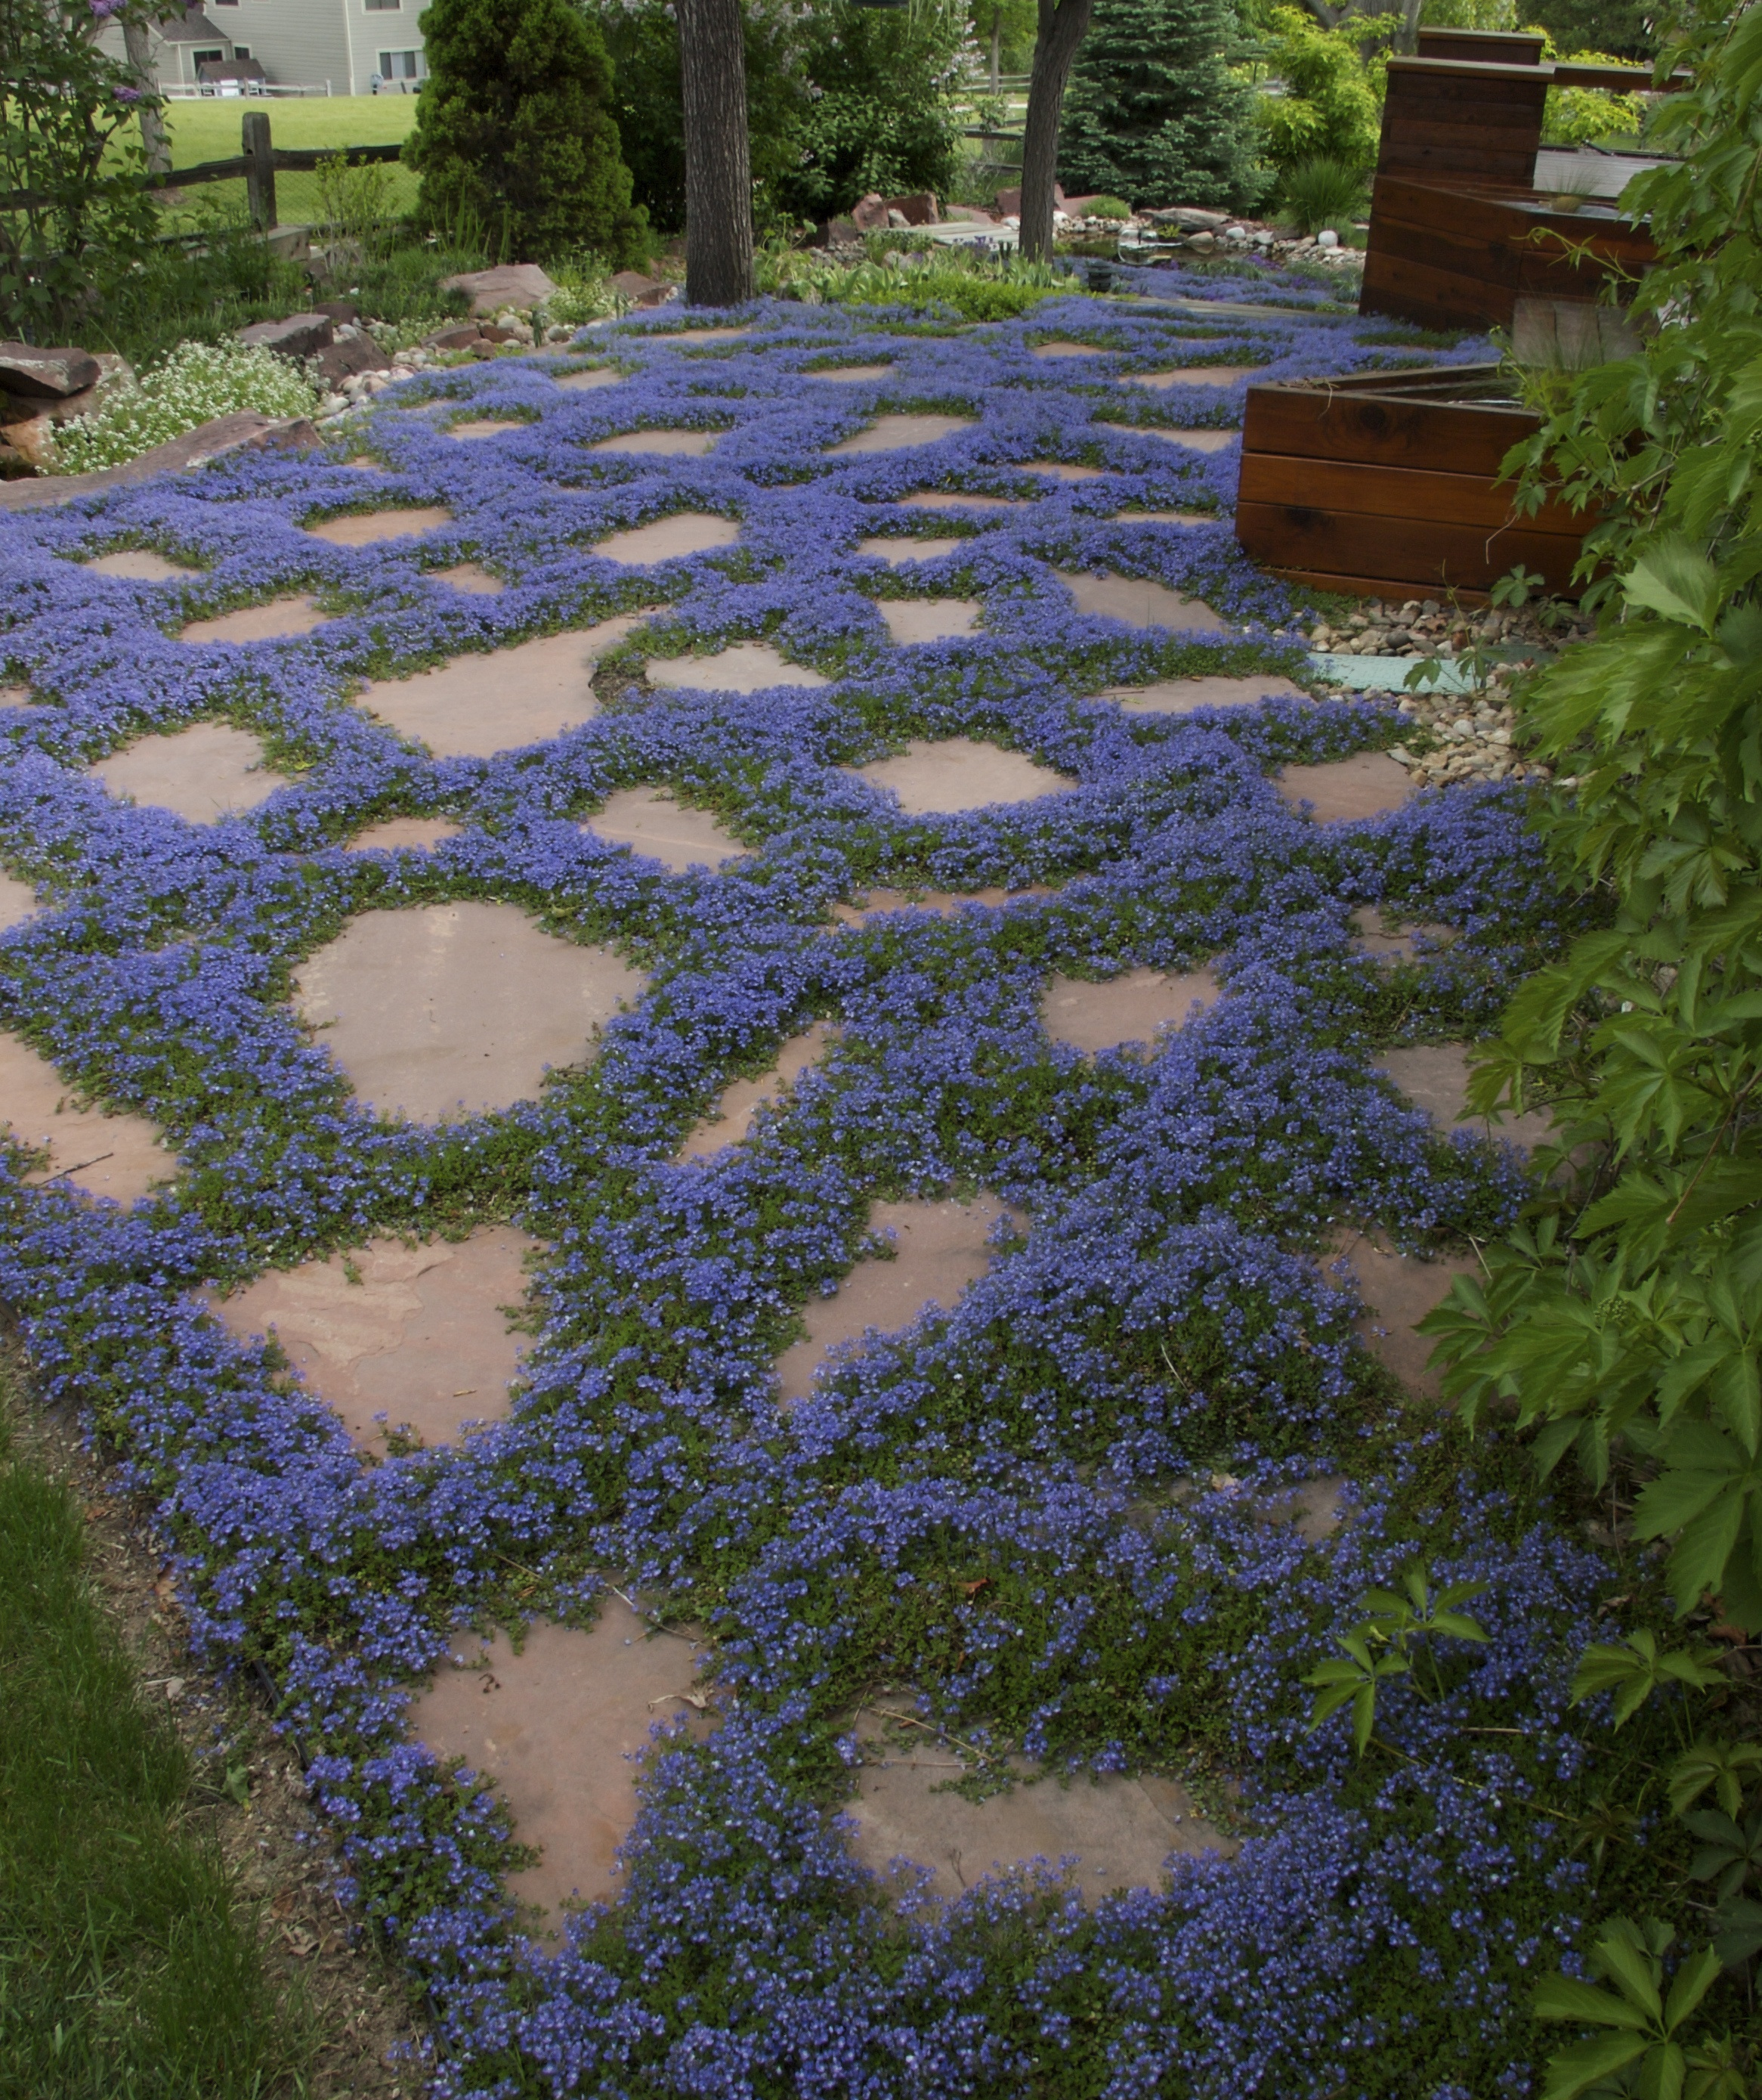
Height: 12”
Width: 15”
Blooms: April to fall
Sun: Full sun to partial shade
Water: Moderate watering
Hardiness: USDA zones 4b-8
Culture: Garden loam
Introduced: 1997
Perennial
Plant has neat mats of oblong, nearly succulent leaves which are evergreen. Its three-inch flower heads are produced from April to autumn, opening white and turning a soft lavender-purple as they age.

Turkish Veronica
Veronica liwanensis
www.plantselect.org

