

**Turkish Veronica**

*Veronica liwanensis*

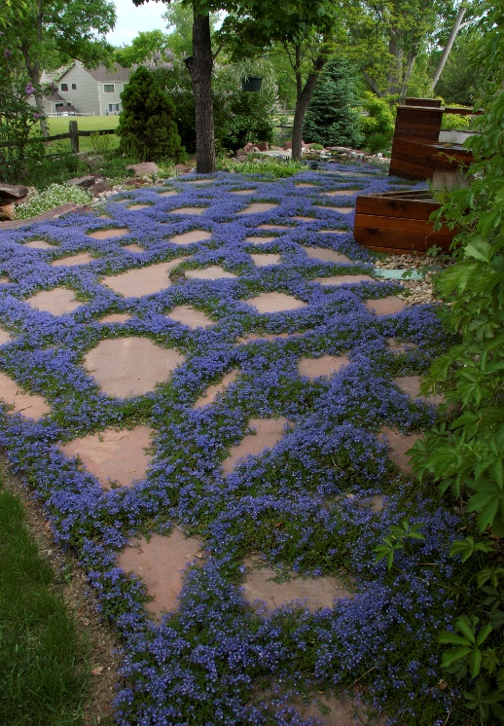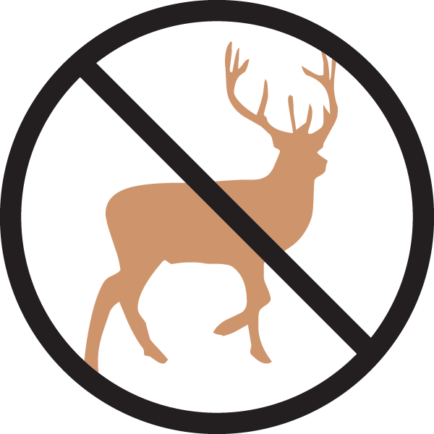

**Height: 2 in. Width: 16-20 in.**

Plant has neat mats of oblong, nearly succulent leaves which are evergreen. Its three-inch flower heads are produced from April to autumn, opening white and turning a soft lavender-purple as they age.

**Culture:** Loam or sandy soil

**Hardiness:** USDA zones 3-10



WIND. HAIL. SNOW. SUN

**BRING IT ON**

www.plantselect.org

