
Turkish Veronica
Veronica liwanensis

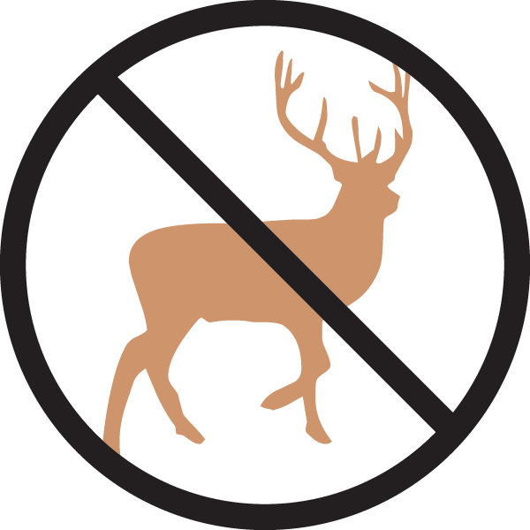

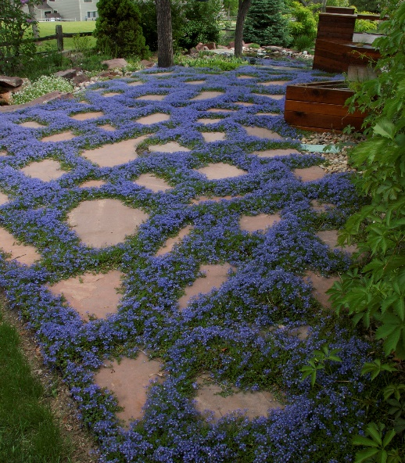





Height: 12 in. Width: 15 in.
Plant has neat mats of oblong, nearly succulent leaves which are evergreen. Its three-inch flower heads are produced from April to autumn, opening white and turning a soft lavender-purple as they age.
Culture: Clay, loam or sandy soil
Hardiness: USDA zones 3-10



WIND. HAIL. SNOW. SUN
BRING IT ON

www.plantselect.org



