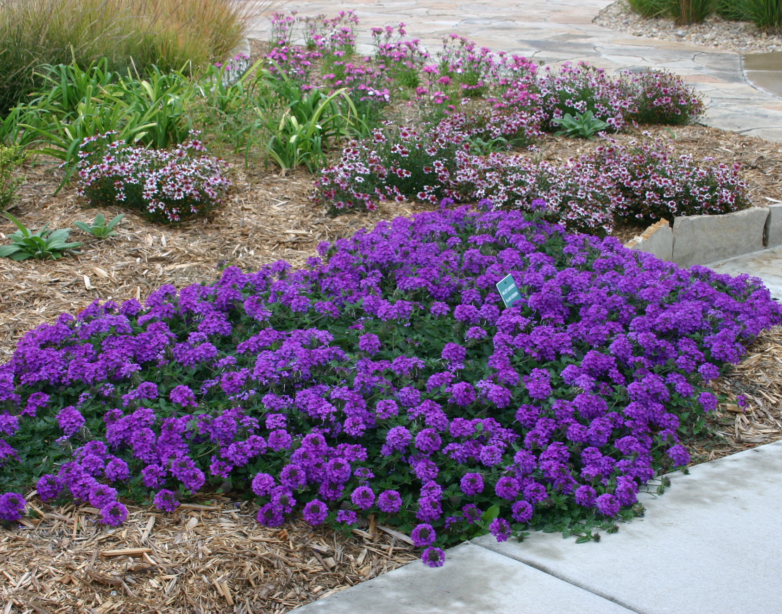



Height: 3-6”
Width: 12-18”
Blooms: May to October
Sun: Full sun
Water: Moderate to xeric
Hardiness: USDA zones 4-8
Culture: Average, clay, or sandy soil
Introduced: 2005
Groundcover
Vibrant lavender flower clusters are held erect above spreading stems with deeply cut leaves. The beautiful groundcover blooms from late spring through frost. A durable Great Plains perennial that is attractive to butterflies.

Valley Lavender® Plains Verbena
Verbena bipinnatifida
www.plantselect.org

