
Valley Lavender® Plains Verbena
Verbena bipinnatifida


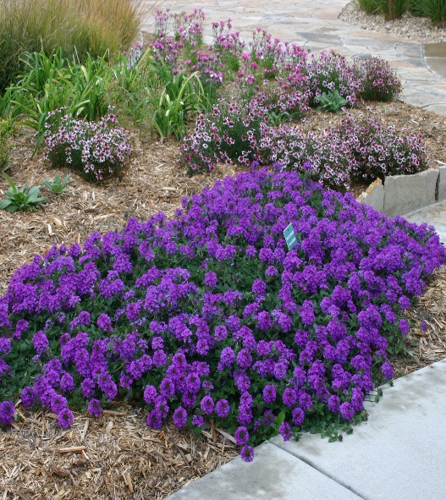

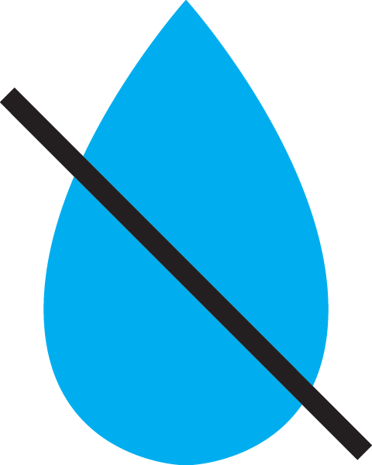



Height: 3-6 in. Width: 12-18 in.
Vibrant lavender flower clusters are held erect above spreading stems with deeply cut leaves. The beautiful groundcover blooms from late spring through frost. A durable Great Plains perennial that is attractive to butterflies.
Culture: Clay, loam or sandy soil
Hardiness: USDA zones 5-8



WIND. HAIL. SNOW. SUN
BRING IT ON

www.plantselect.org



