

**Valley Lavender® Plains Verbena**

*Verbena bipinnatifida*

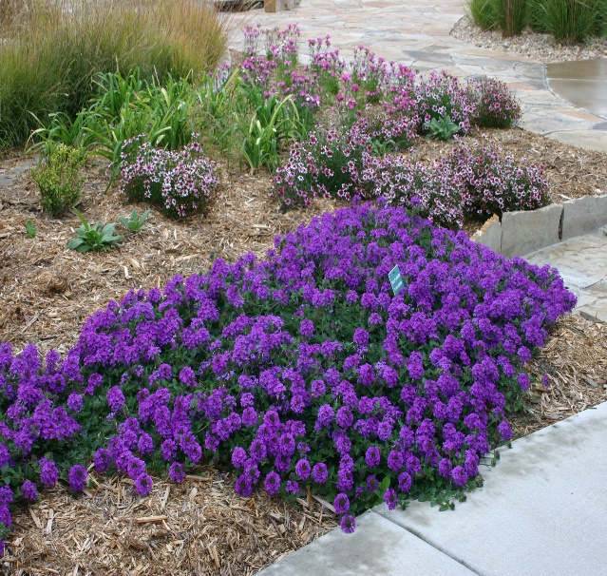

**Height: 3-6 in. Width: 12-18 in.**

Vibrant lavender flower clusters are held erect above spreading stems with deeply cut leaves. The beautiful groundcover blooms from late spring through frost. A durable Great Plains perennial that is attractive to butterflies.

**Culture:** Clay, loam or sandy soil

**Hardiness:** USDA zones 5-8



WIND. HAIL. SNOW. SUN

**BRING IT ON**

www.plantselect.org

