

**Tushar bluemat penstemon**

*Pensemon xylus*

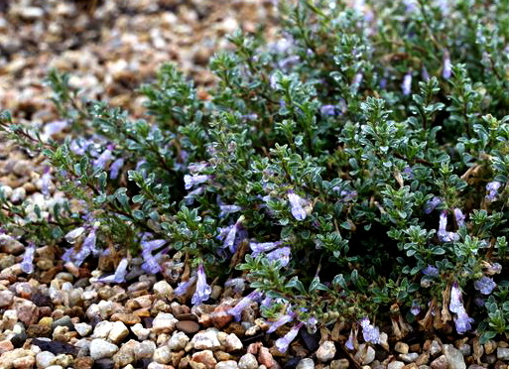

**Height: 3-6 in. Width: 15-18 in.**

Native to the Tushar mountain range of Utah, this tough and tiny penstemon features blue-violet flowers from June to August against steel-blue foliage. It’s happy in gritty soils, full sun and xeric conditions. Ideal for rock gardens, troughs or crevice gardens. Evergreen!

**Culture:** Clay, loam, well-drained soil

**Hardiness:** USDA zones 5a-8b



WIND. HAIL. SNOW. SUN

**BRING IT ON**

www.plantselect.org

