

**Golden Candles**

*Thermopsis lupinoides*

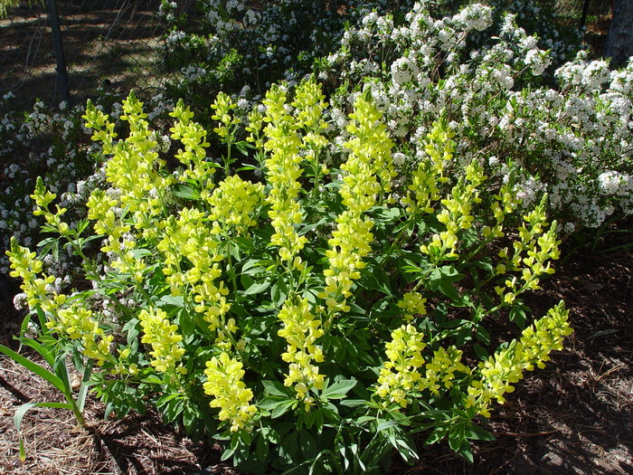

**Height: 24-33 in. Width: 20-30 in.**

Thick clusters of bright yellow in April taper into elegant yellow golden candle spires in late spring. Attractive mounds of lupine-like foliage persist the rest of the summer. A robust, adaptable perennial providing cheerful color early in the growing season.

**Culture:** Loam or sandy soil

**Hardiness:** USDA zones 4-8



WIND. HAIL. SNOW. SUN

**BRING IT ON**

www.plantselect.org