
Partridge Feather
Tanacetum densum ssp. Amani

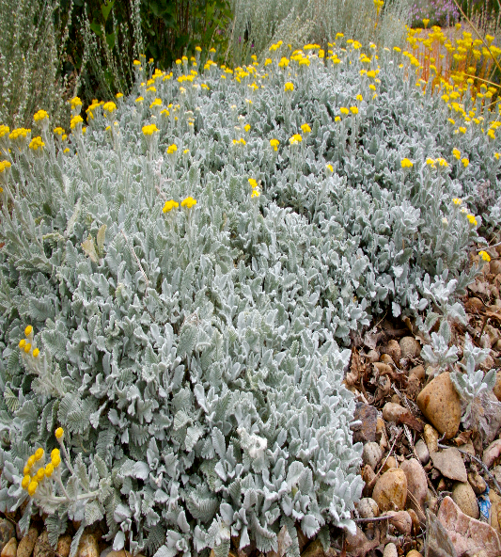







Height: 4-6 in. Width: 18-24 in.
Plush ever-silver mats of gorgeous feathery foliage will thrive in dry gardens with good drainage. Golden button flowers appear for a short time in summer. Introduced from Southeastern Turkey in the 1950s by Peter Davis.Roll out the carpet – this time it’s silver!
Culture: Loam or sandy soil
Hardiness: USDA zones 4-9



WIND. HAIL. SNOW. SUN
BRING IT ON

www.plantselect.org



