

**Partridge Feather**

*Tanacetum densum* ssp. Amani

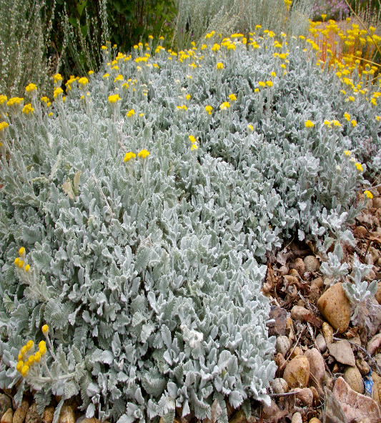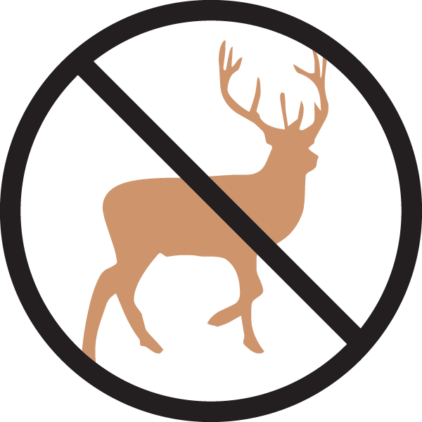

**Height: 4-6 in. Width: 18-24 in.**

Plush ever-silver mats of gorgeous feathery foliage will thrive in dry gardens with good drainage. Golden button flowers appear for a short time in summer. Introduced from Southeastern Turkey in the 1950s by Peter Davis.Roll out the carpet – this time it’s silver!

**Culture:** Loam or sandy soil

**Hardiness:** USDA zones 4-9



WIND. HAIL. SNOW. SUN

**BRING IT ON**

www.plantselect.org

