
Dalmatian Daisy
Tanacetum cinerariifolium



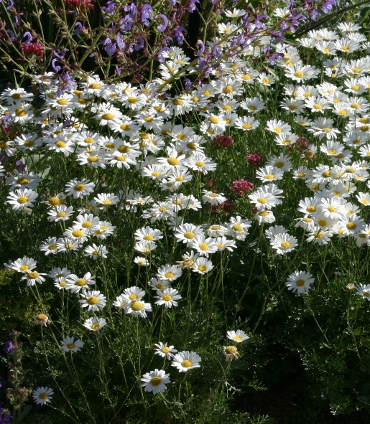





Height: 16-20 in. Width: 24-30 in.
The compact mound of silvery, ferny foliage is decorative at all times, but much of the year it is obscured under a dome of shimmering white daisies. Aromatic and pest-free, this is the perfect white daisy for drier gardens and landscapes.
Culture: Sandy loam
Hardiness: USDA zones 4-10



WIND. HAIL. SNOW. SUN
BRING IT ON

www.plantselect.org



