



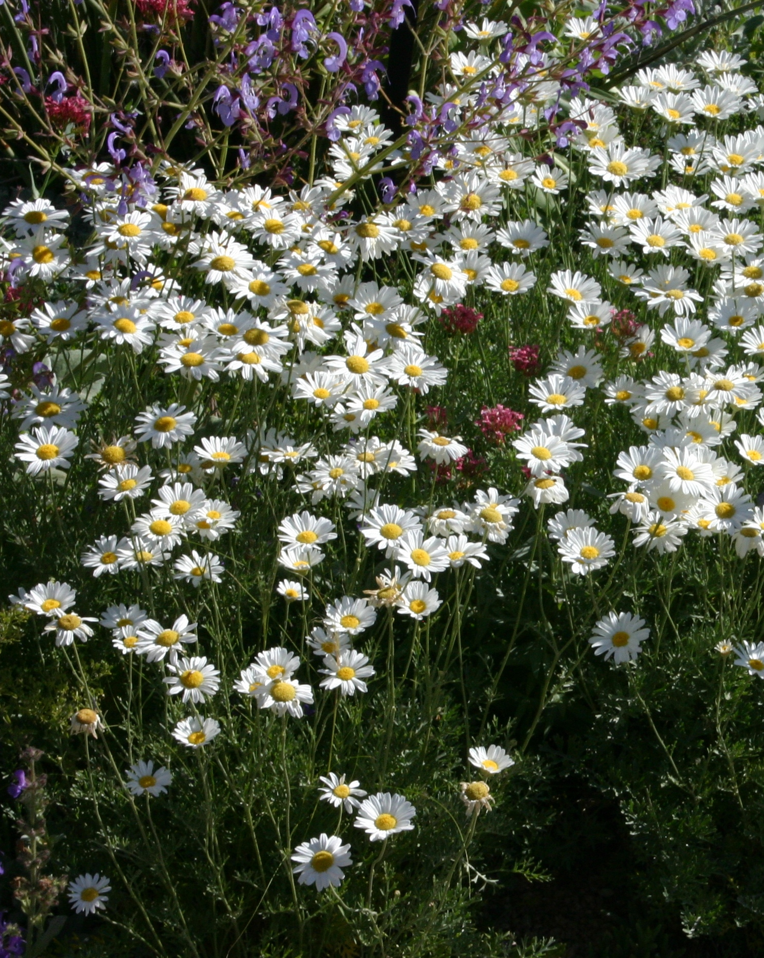
Height: 16-20”
Width: 24-30”
Blooms: May to July
Sun: Full sun to partial shade
Water: Moderate to dry
Hardiness: USDA zones 4-10 (up to 8,000’)
Culture: Sandy loam soils
Introduced: 2012
Perennial
The compact mound of silvery, ferny foliage is decorative at all times, but much of the year it is obscured under a dome of shimmering white daisies. Aromatic and pest-free, this is the perfect white daisy for drier gardens and landscapes.

Dalmatian Daisy
Tanacetum cinerariifolium
www.plantselect.org

