

**Dalmatian Daisy**

*Tanacetum cinerariifolium*

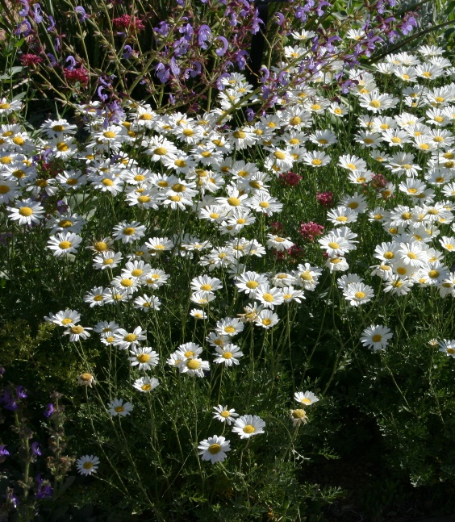

**Height: 16-20 in. Width: 24-30 in.**

The compact mound of silvery, ferny foliage is decorative at all times, but much of the year it is obscured under a dome of shimmering white daisies. Aromatic and pest-free, this is the perfect white daisy for drier gardens and landscapes.

**Culture:** Sandy loam

**Hardiness:** USDA zones 4-10



WIND. HAIL. SNOW. SUN

**BRING IT ON**

www.plantselect.org

