

**Summer Frost Pink Candy**

*Stachys lavandulifolia* ‘P020S’(silver form)

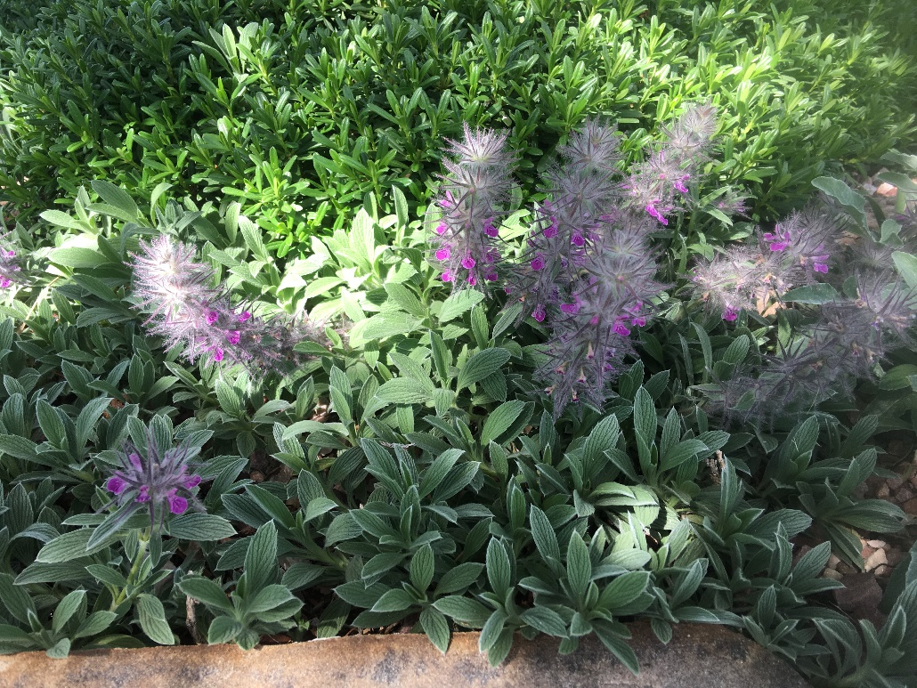

**Height: 8-10 in. Width: 12-18 in.**

An elegant, silver sport of Pink Cotton lamb’s ear grown primarily for its bright, silver-haired leaves that add beauty and texture in the garden. Flossy clusters of pink trumpets add to the plants striking foliage that fills in nicely around other ornamental plants.

**Culture:** Loam or sandy soil

**Hardiness:** USDA zones 5-9



WIND. HAIL. SNOW. SUN

**BRING IT ON**

www.plantselect.org