

**Pink Cotton Lamb’s Ear**

*Stachys lavandulifolia* (green form)

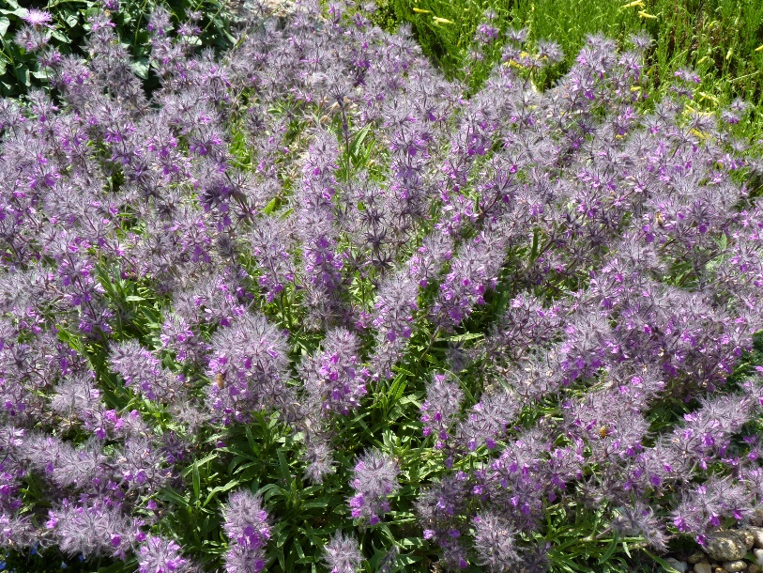

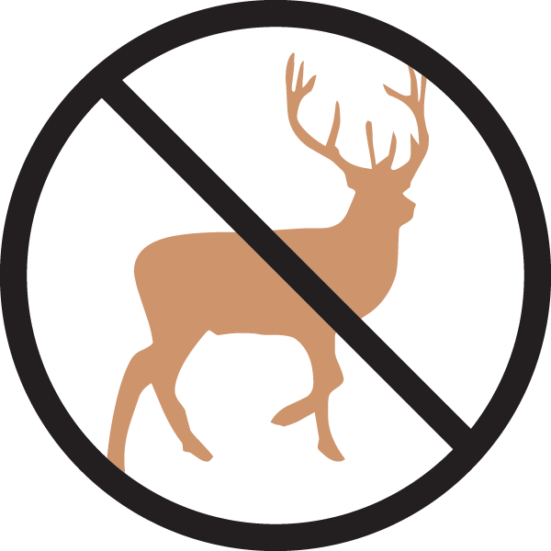

**Height: 8-10 in. Width: 12-18 in.**

A superior selection of a Turkish wildflower for the front of a border or xeriscape garden. Low mats of soft, attractive foliage with flossy clusters of pink trumpets in late spring-early summer that really do suggest cotton candy!

**Culture:** Loam or sandy soil

**Hardiness:** USDA zones 5-9



WIND. HAIL. SNOW. SUN

**BRING IT ON**

www.plantselect.org