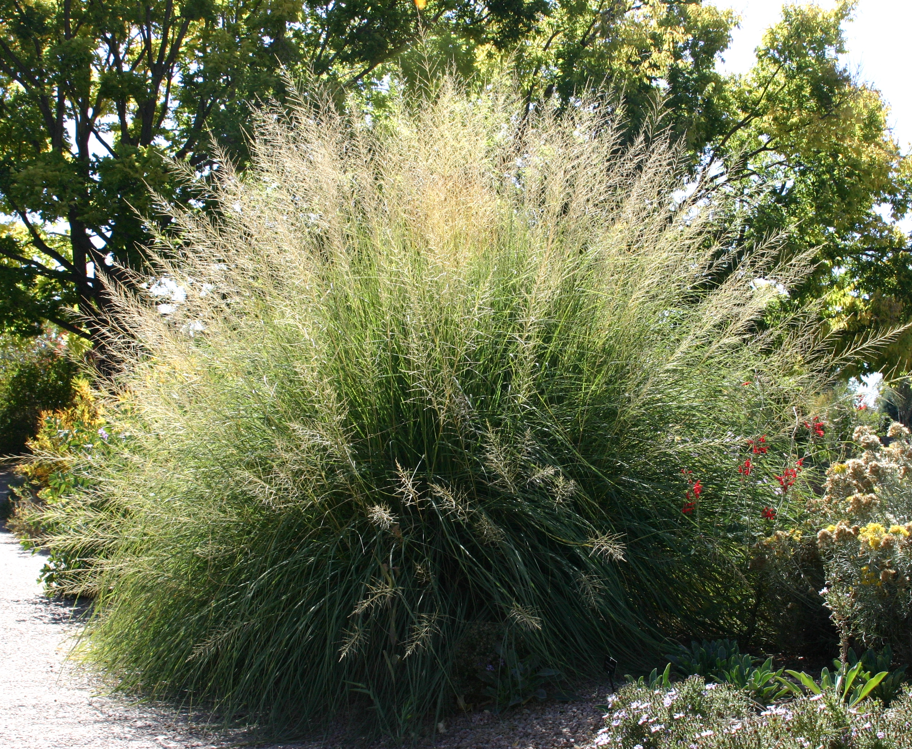



Height: 5-7’
Width: 3-5’
Blooms: Late summer to fall
Sun: Full sun to partial shade
Water: Moderate to very dry
Hardiness: USDA zones 5-8 (up to 7,000’)
Culture: Average, clay, or sandy soil
Introduced: 2006
Perennial
Extravagant fountains of luxuriant foliage create a focal point in the Xeriscape™ garden. A wonderful southwestern native alternative to Pampas grass.

Giant sacaton
Sporobolus wrightii
www.plantselect.org

