
Giant sacaton
Sporobolus wrightii








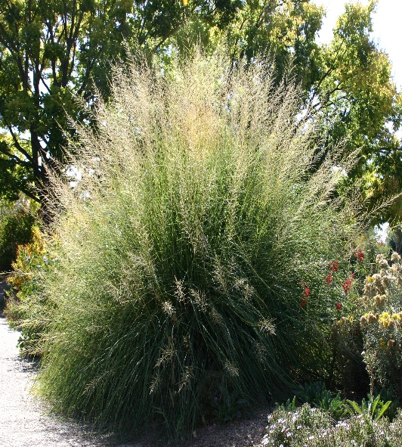

Height: 5-7 ft. Width: 3-5 ft.
Extravagant fountains of luxuriant foliage create a focal point in the Xeriscape™ garden. A wonderful southwestern native alternative to Pampas grass.
Culture: Clay, loam or sandy soil
Hardiness: USDA zones 5-8



WIND. HAIL. SNOW. SUN
BRING IT ON

www.plantselect.org



