
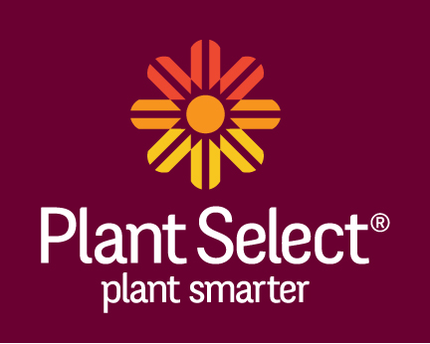
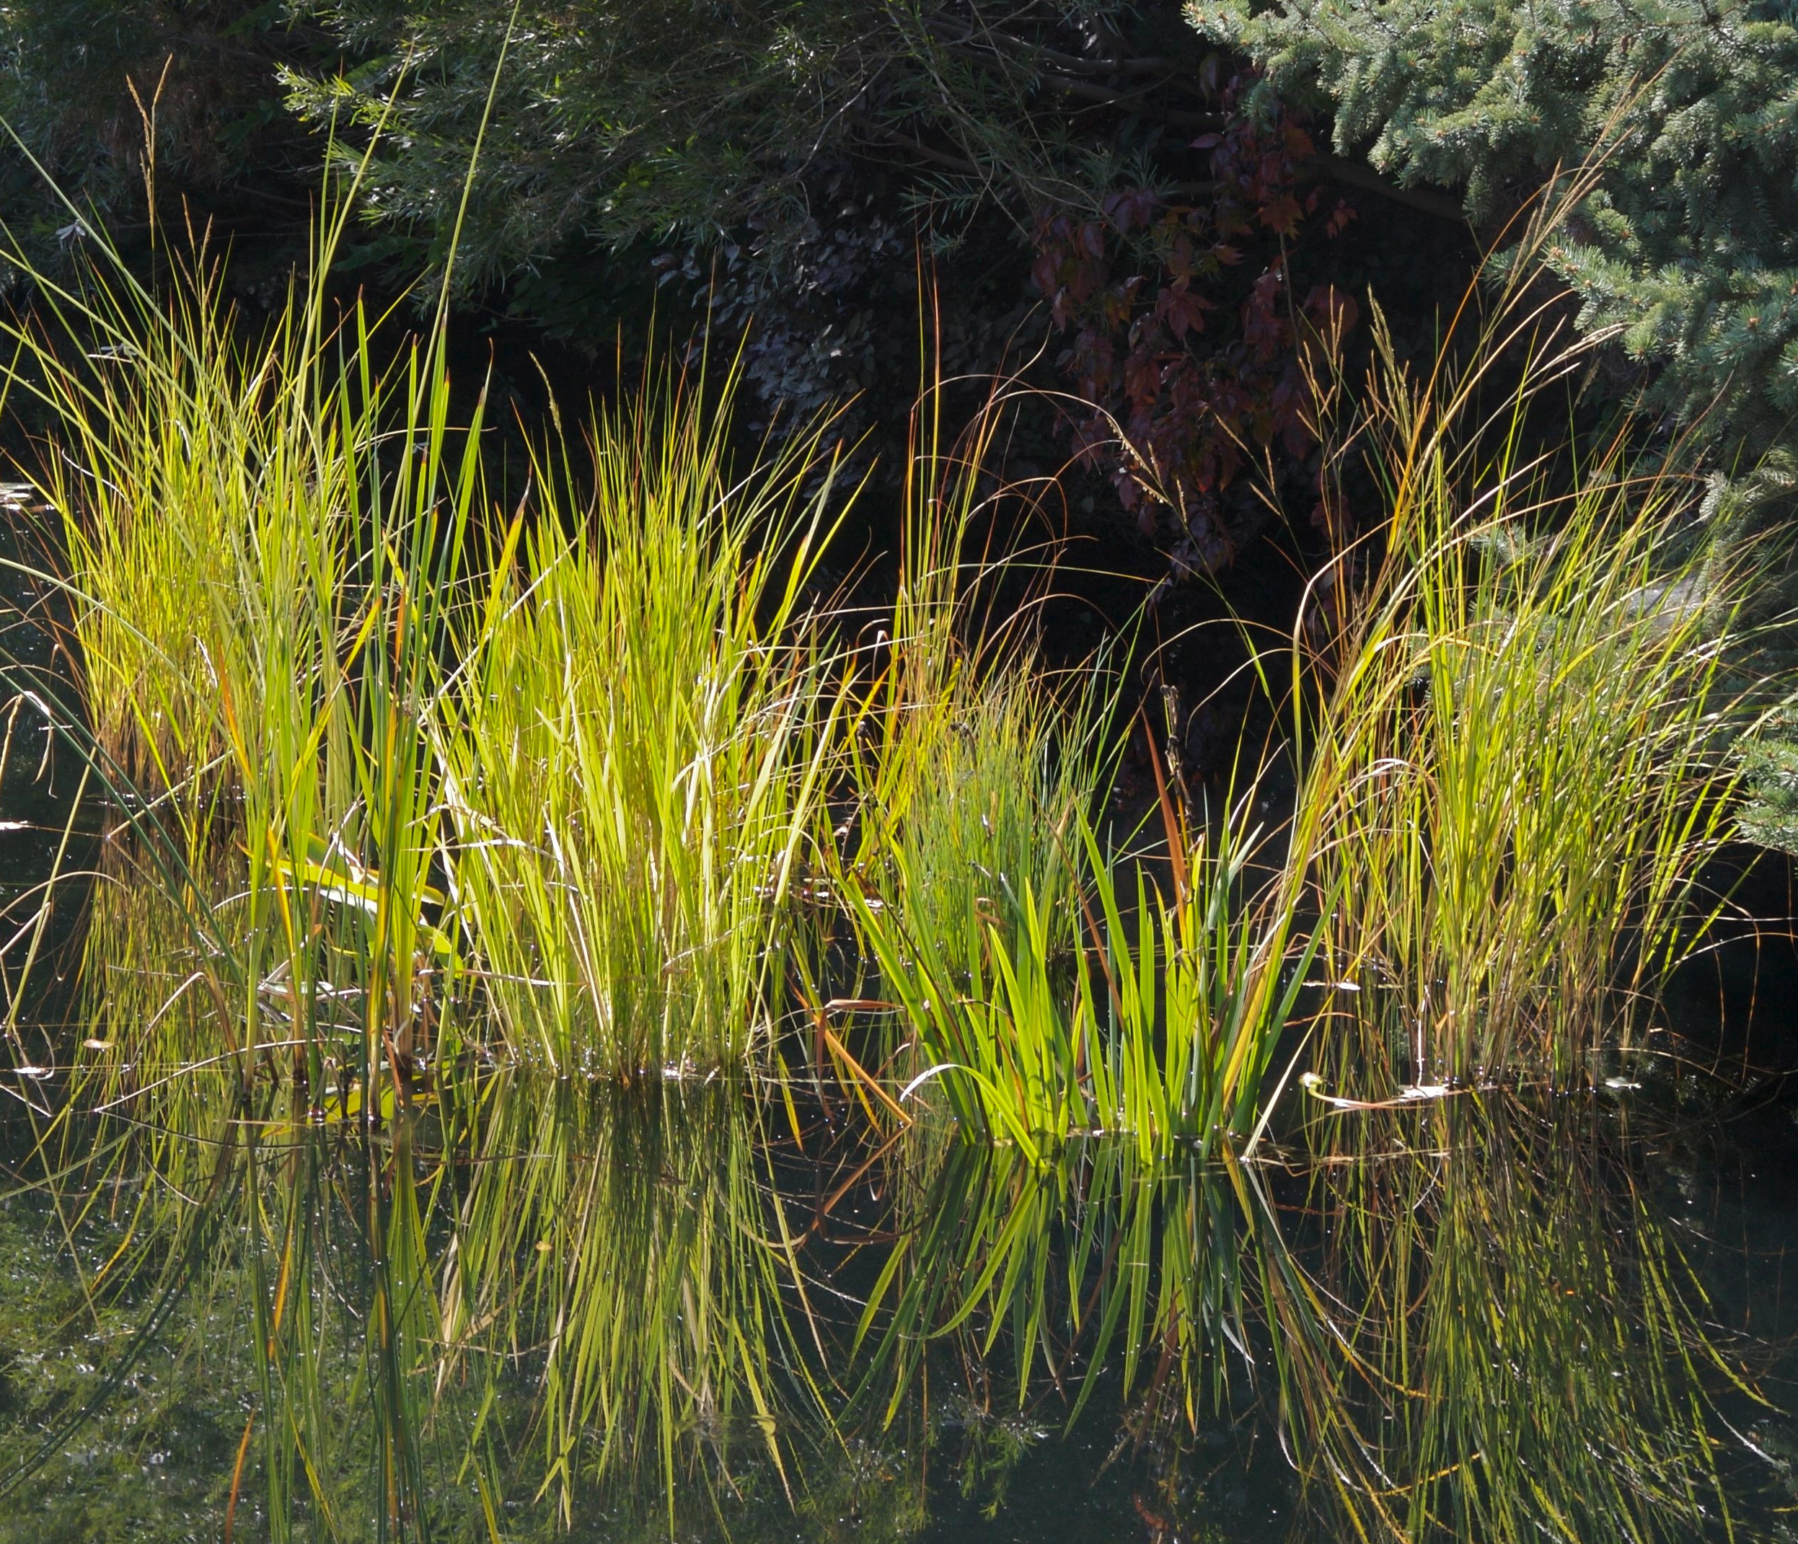
Height: 20-30”
Width: 20-30”
Sun: Full sun to partial shade
Water: Best submerged in water 1-6” deep
Hardiness: USDA zones 4-8
Culture: Heavy clay loam
Introduced: 1999
Aquatic Perennial
This dramatic native grass of wetlands makes a superlative container plant for a pond garden. Graceful, weeping form takes on rich golden tints in autumn, glowing in sunset light. Keep in container to control spreading.

Prairie Cordgrass
Spartina pectinata
www.plantselect.org

